PREA Peer Educator

Training Slides

Slide 2
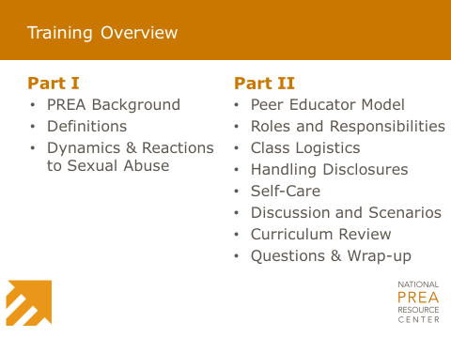
____________________________
____________________________
____________________________
____________________________
____________________________
____________________________
____________________________
 | Part I: PREA Background
Slide 3 | Slide 4
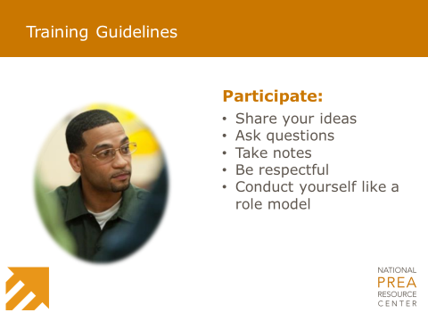 | 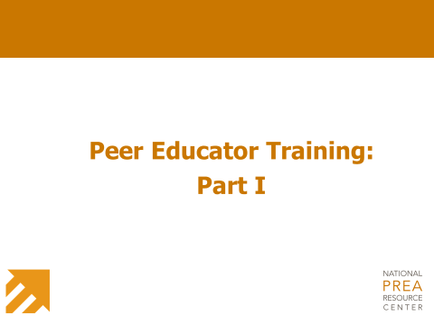
____________________________  ____________________________  ____________________________  ____________________________  ____________________________  ____________________________  ____________________________ | ____________________________  ____________________________  ____________________________  ____________________________  ____________________________  ____________________________  ____________________________
Slide 5 |  | Slide 6
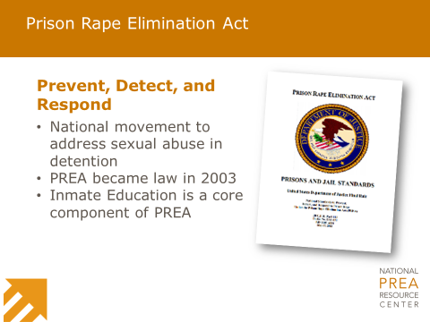 |  | 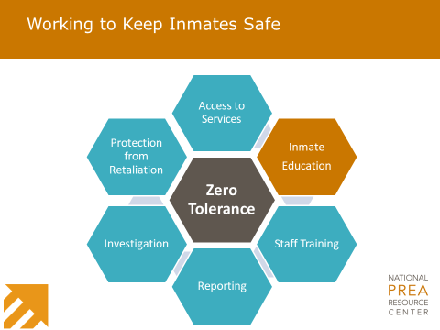
____________________________  ____________________________  ____________________________  ____________________________  ____________________________  ____________________________  ____________________________ |  | ____________________________  ____________________________  ____________________________  ____________________________  ____________________________  ____________________________  ____________________________
Slide 7 | Slide 8
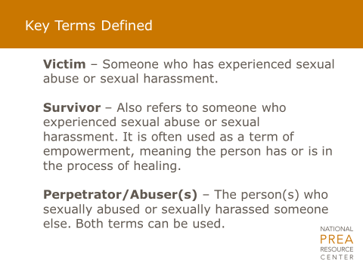 | 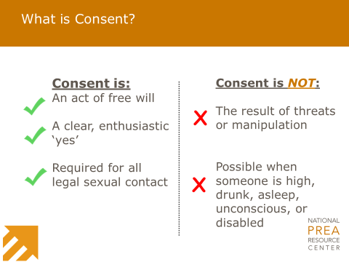
____________________________  ____________________________  ____________________________  ____________________________  ____________________________  ____________________________  ____________________________ | ____________________________  ____________________________  ____________________________  ____________________________  ____________________________  ____________________________  ____________________________

Slide 9 | Slide 10
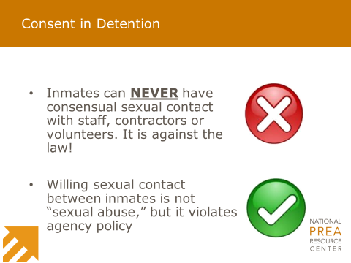 | 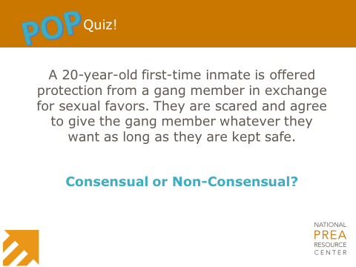
____________________________  ____________________________  ____________________________  ____________________________  ____________________________  ____________________________  ____________________________ | ____________________________  ____________________________  ____________________________  ____________________________  ____________________________  ____________________________  ____________________________

Slide 11 | Slide 12
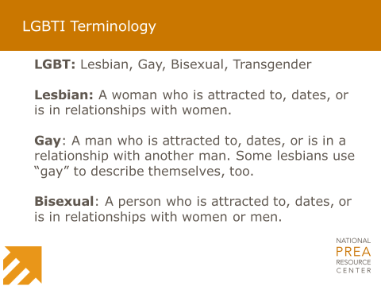 | 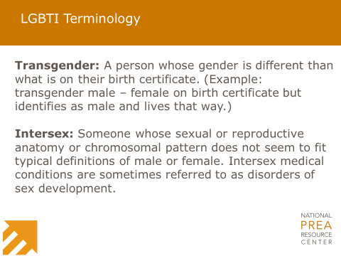
____________________________  ____________________________  ____________________________  ____________________________  ____________________________  ____________________________  ____________________________ | ____________________________  ____________________________  ____________________________  ____________________________  ____________________________  ____________________________  ____________________________

Slide 13 | Slide 14
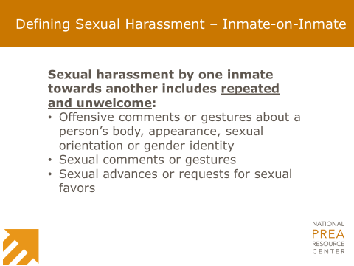 | 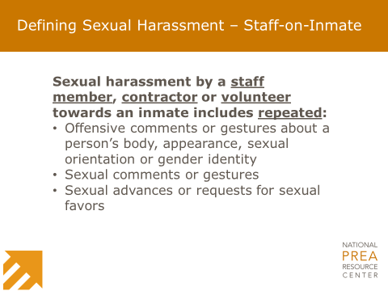
____________________________  ____________________________  ____________________________  ____________________________  ____________________________  ____________________________  ____________________________ | ____________________________  ____________________________  ____________________________  ____________________________  ____________________________  ____________________________  ____________________________

Slide 15 | Slide 16
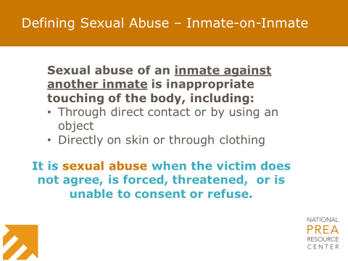 | 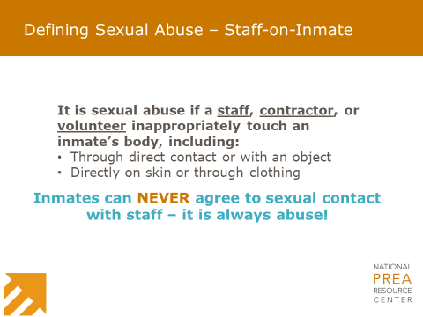
____________________________  ____________________________  ____________________________  ____________________________  ____________________________  ____________________________  ____________________________ | ____________________________  ____________________________  ____________________________  ____________________________  ____________________________  ____________________________  ____________________________

Slide 17 | Slide 18
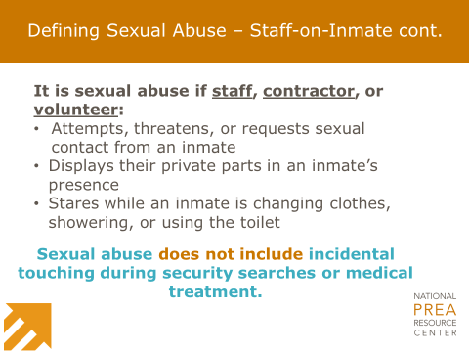 | 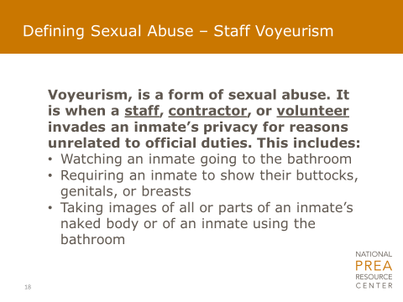
____________________________  ____________________________  ____________________________  ____________________________  ____________________________  ____________________________  ____________________________ | ____________________________  ____________________________  ____________________________  ____________________________  ____________________________  ____________________________  ____________________________

Part I: Dynamics and Reactions to Sexual Abuse
Slide 19 | Slide 20
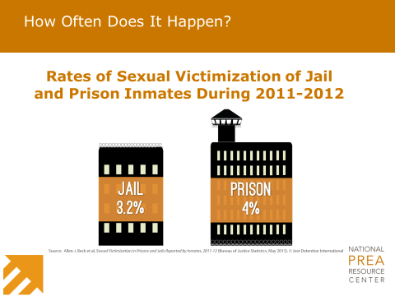 | 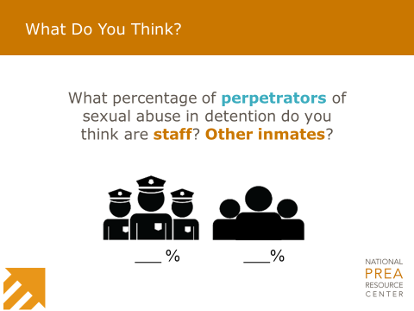
____________________________  ____________________________  ____________________________  ____________________________  ____________________________  ____________________________  ____________________________ | ____________________________  ____________________________  ____________________________  ____________________________  ____________________________  ____________________________  ____________________________

Slide 21 | Slide 22
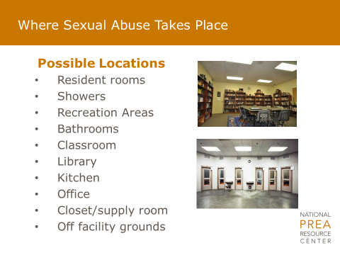 | 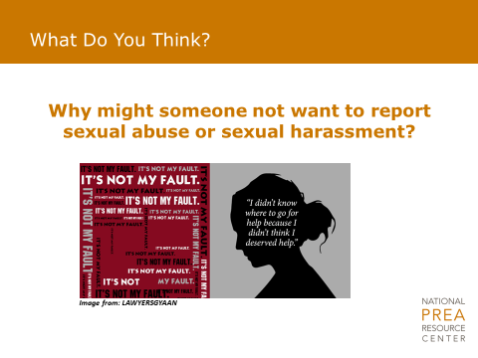
____________________________  ____________________________  ____________________________  ____________________________  ____________________________  ____________________________  ____________________________ | ____________________________  ____________________________  ____________________________  ____________________________  ____________________________  ____________________________  ____________________________

Slide 23 | Slide 24
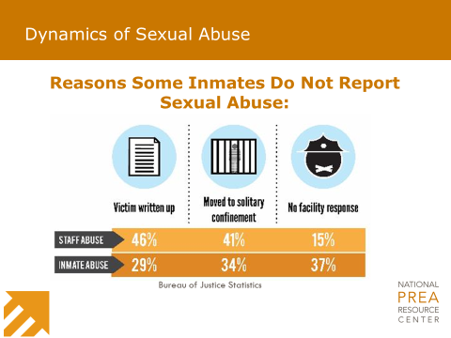 | 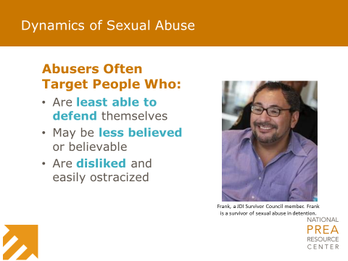
____________________________  ____________________________  ____________________________  ____________________________  ____________________________  ____________________________  ____________________________ | ____________________________  ____________________________  ____________________________  ____________________________  ____________________________  ____________________________  ____________________________

Slide 25 | Slide 26
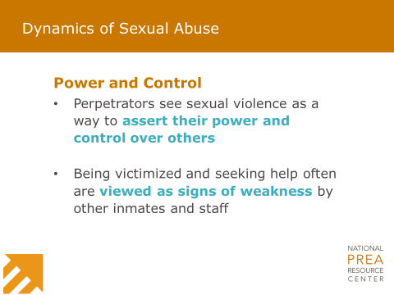
____________________________  ____________________________  ____________________________  ____________________________  ____________________________  ____________________________  ____________________________ | ____________________________  ____________________________  ____________________________  ____________________________  ____________________________  ____________________________  ____________________________

Slide 27 | Slide 28
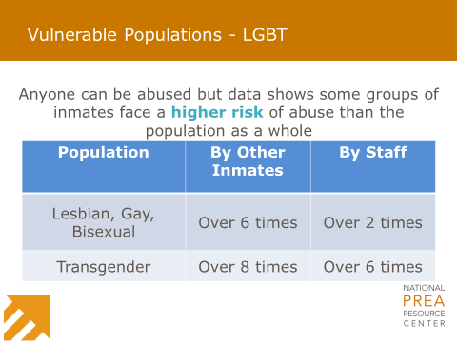 | 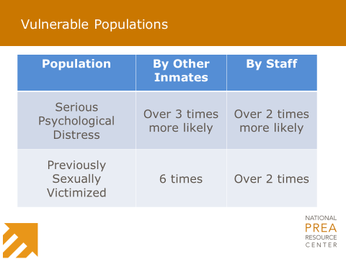
____________________________  ____________________________  ____________________________  ____________________________  ____________________________  ____________________________  ____________________________ | ____________________________  ____________________________  ____________________________  ____________________________  ____________________________  ____________________________  ____________________________

Slide 29 | Slide 30
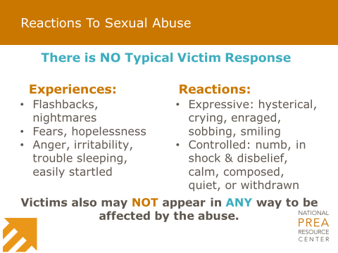 | 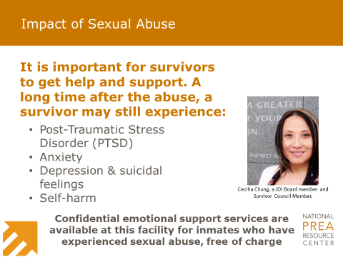
____________________________  ____________________________  ____________________________  ____________________________  ____________________________  ____________________________  ____________________________ | ____________________________  ____________________________  ____________________________  ____________________________  ____________________________  ____________________________  ____________________________

Part II: Peer Educator Position
Slide 31 | Slide 32
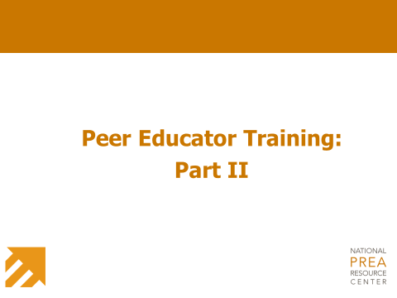 | 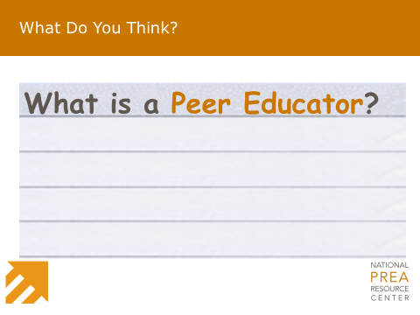
____________________________  ____________________________  ____________________________  ____________________________  ____________________________  ____________________________  ____________________________ | ____________________________  ____________________________  ____________________________  ____________________________  ____________________________  ____________________________  ____________________________

Slide 33 |  |  | Slide 34
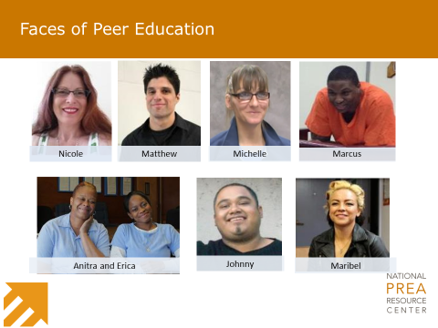 |  |  | 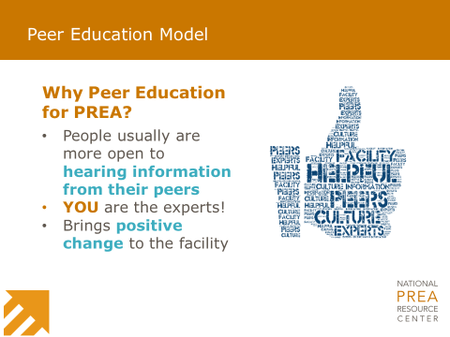
____________________________  ____________________________  ____________________________  ____________________________  ____________________________  ____________________________  ____________________________ |  |  | ____________________________  ____________________________  ____________________________  ____________________________  ____________________________  ____________________________  ____________________________
 |  |  | Part II: Roles and Responsibilities
Slide 35 |  |  | Slide 36
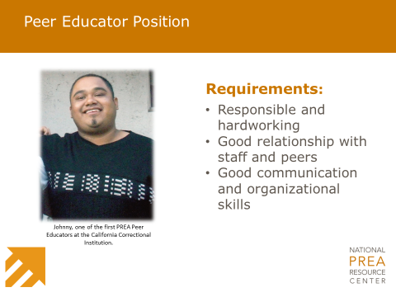 |  |  | 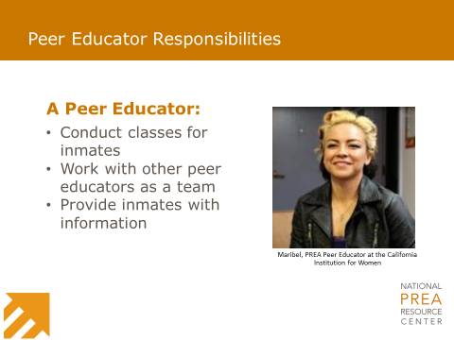
____________________________  ____________________________  ____________________________  ____________________________  ____________________________  ____________________________  ____________________________ |  |  | ____________________________  ____________________________  ____________________________  ____________________________  ____________________________  ____________________________  ____________________________
Slide 37 |  | Slide 38
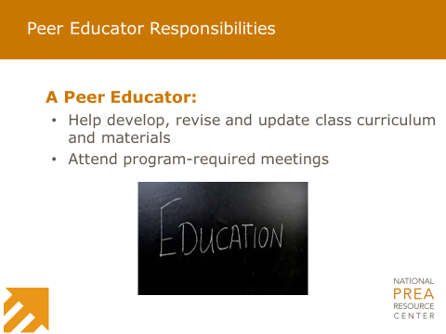 |  | 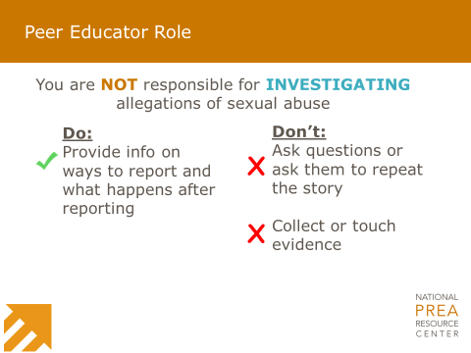
____________________________  ____________________________  ____________________________  ____________________________  ____________________________  ____________________________  ____________________________ |  | ____________________________  ____________________________  ____________________________  ____________________________  ____________________________  ____________________________  ____________________________
 |  |  | Part II: Class Logistics
Slide 39 | Slide 40
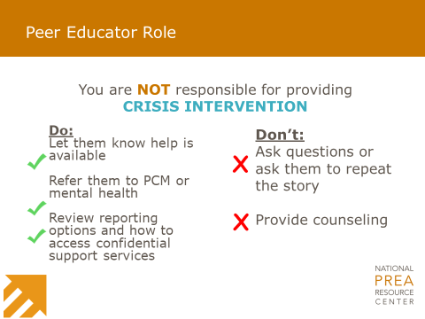 | 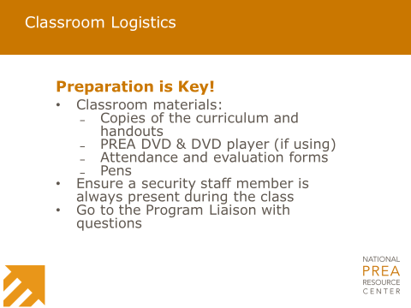
____________________________  ____________________________  ____________________________  ____________________________  ____________________________  ____________________________  ____________________________ | ____________________________  ____________________________  ____________________________  ____________________________  ____________________________  ____________________________  ____________________________
Slide 41 |  |  | Slide 42
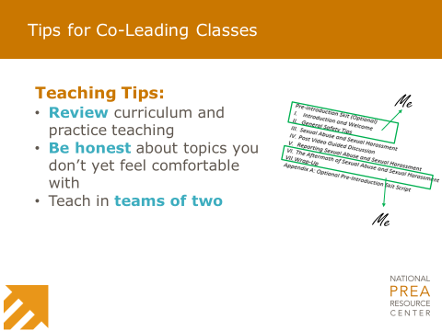 |  |  | 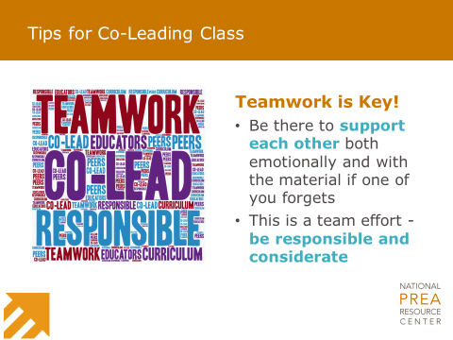
____________________________  ____________________________  ____________________________  ____________________________  ____________________________  ____________________________  ____________________________ |  |  | ____________________________  ____________________________  ____________________________  ____________________________  ____________________________  ____________________________  ____________________________

Slide 43 |  | Slide 44
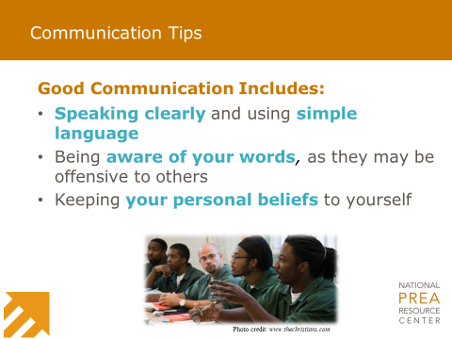 |  | 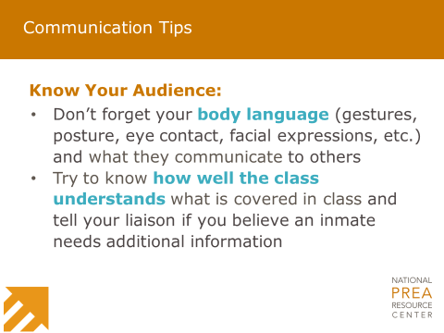
____________________________  ____________________________  ____________________________  ____________________________  ____________________________  ____________________________  ____________________________ |  | ____________________________  ____________________________  ____________________________  ____________________________  ____________________________  ____________________________  ____________________________
Part II: Handling Disclosures | Part II: Self-Care
Slide 45 |  | Slide 46
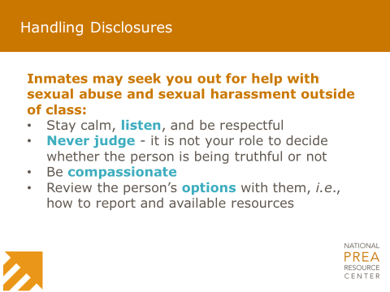 |  | 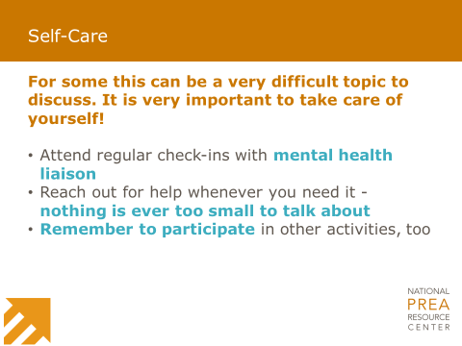
____________________________  ____________________________  ____________________________  ____________________________  ____________________________  ____________________________ |  | ____________________________  ____________________________  ____________________________  ____________________________  ____________________________  ____________________________

 | Part II: Discussion and Scenarios
Slide 47 |  | Slide 48
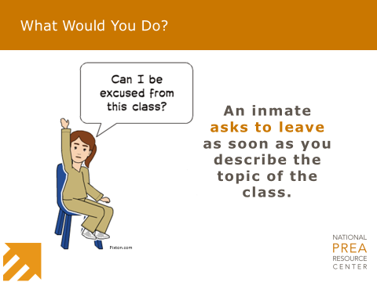 |  | 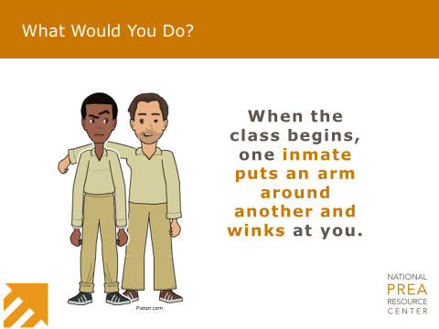
____________________________  ____________________________  ____________________________  ____________________________  ____________________________  ____________________________  ____________________________ |  | ____________________________  ____________________________  ____________________________  ____________________________  ____________________________  ____________________________  ____________________________
Slide 49
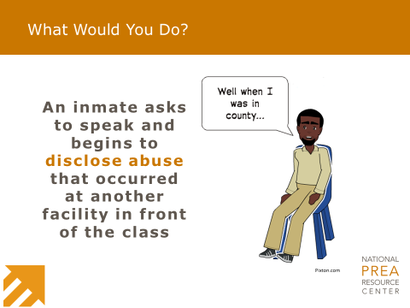
____________________________
____________________________
____________________________
____________________________
____________________________
____________________________
____________________________

Slide 50
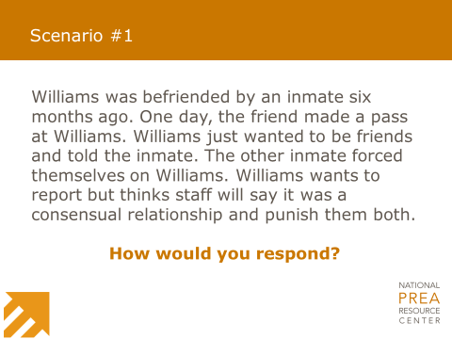
_____________________________________________________________
_____________________________________________________________
_____________________________________________________________
_____________________________________________________________
_____________________________________________________________

Slide 51
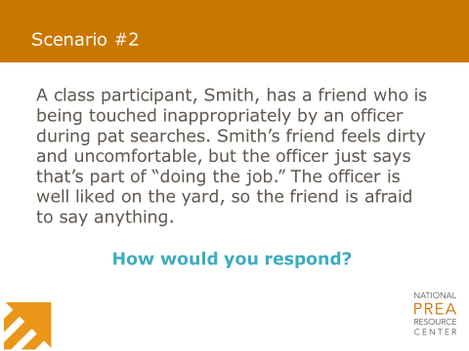
_____________________________________________________________
_____________________________________________________________
_____________________________________________________________
_____________________________________________________________
_____________________________________________________________

Slide 52
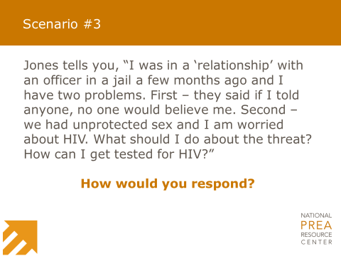
_____________________________________________________________
_____________________________________________________________
_____________________________________________________________
_____________________________________________________________
_____________________________________________________________

Part II: Curriculum Review |  | Part II: Questions & Wrap-up
Slide 53 |  | Slide 54
____________________________  ____________________________  ____________________________  ____________________________  ____________________________  ____________________________  ____________________________ |  | ____________________________  ____________________________  ____________________________  ____________________________  ____________________________  ____________________________  ____________________________
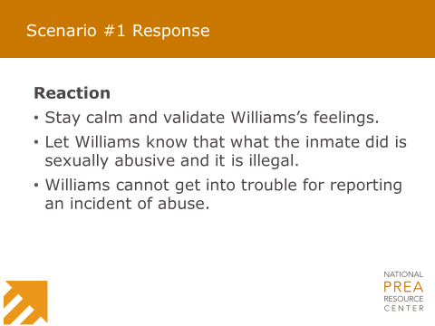 | 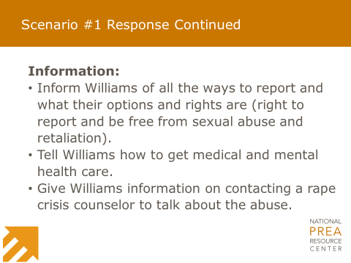

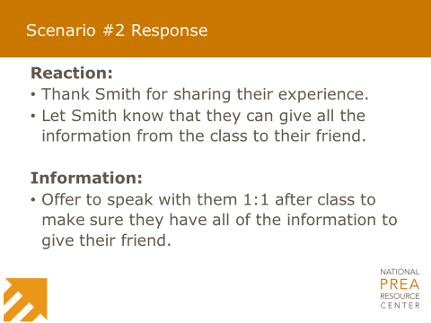 | 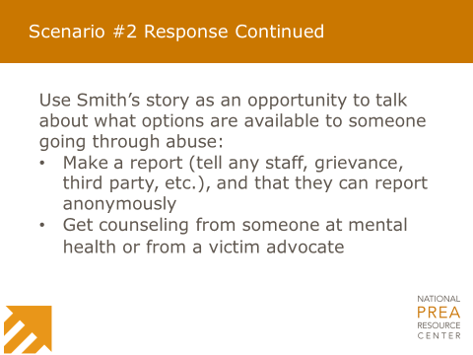
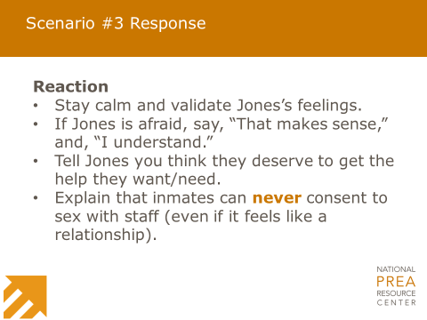 | 