PREA

Peer Educator Training Annotated Trainer’s Guide

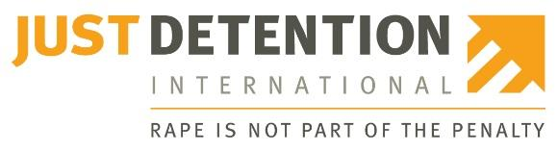
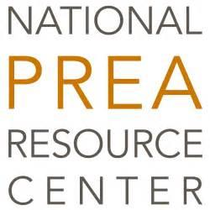
Length: approximately 4 hours (this can be broken into two parts)
Module Description:
This interactive training was developed to educate Peer Educators about their roles and PREA. It includes a presentation as well as scenarios and discussion points to reinforce content. The training concludes with a review of the PREA Peer Education Class Curriculum.

Module Objectives:
- Part I – Educate Peer Educators about PREA including: definitions of sexual abuse and sexual harassment, dynamics of sexual abuse in confinement, and vulnerable populations.
- Part II – Educate Peer Educators on their roles and responsibilities, including class logistics, appropriate interactions with other inmates, and review of the PREA Peer Education Class Curriculum.

Materials:
- Copies of “Training Slides for Peer Educators” for each Peer Educator (print double-sided in color if possible).
- PREA Peer Education Class Curriculum for each Peer Educator (print single-sided).
- Pens/pencils for taking notes.
- Flipchart paper.
- Markers.

Optional Resources:
- Folders for Peer Educators to keep their Peer Education materials organized. This also helps to professionalize the role of Peer Educator.
- Video: “PREA: What You Need to Know”
www.youtube.com/embed/ag-__vbx5Mg

How to Use This Guide:
This guide is intended to support the training materials shared with peer educators. The left-hand column shows each training slide; the right-hand column provides training guidance. For example, bolded text is a sample script, and can be adapted as needed to align with agency/facility policy, including adding relevant information to [bracketed] text. The italicized text provides directions for the trainer.

This guide should be used in conjunction with “Training Slides for Peer Educators,” which provides space for Peer Educators to take notes during the training. Each slide is numbered to help direct trainees to the correct material throughout the training.

Invite facility staff who will work with the peer educators to participate in the training. It is ideal for them to participate in the entire training. If that is not possible, they should at least join for Part II on the logistics of the PREA Peer Education classes.

Note: The term “inmate” is used throughout. Peer education programs have been used primarily in adult prisons and jails, therefore “inmate” aligns with the PREA standards for these types of facilities. However, community confinement and juvenile facilities can also use these resources and the guidance therein to adopt peer education programs for residents. Trainers are encouraged to modify the language here and in “Training Slides for Peer Educators” as needed.
Slide Contents | Trainer’s Narrative/Notes
Slide 1: Title Slide  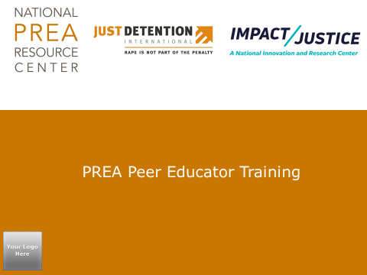 | Welcome everyone to the training. Hand out training slides and pens/pencils to all participants.  Thank you for participating in the PREA Peer Education program. My name is _____________, and I am the _______________.  Each of you has received materials for this training which are yours to keep. You will see that there is space for you to take notes. I encourage you to do so. The information that we share during this training will help you to answer questions during or after a PREA Peer Education Class.  If you are giving them folders, let them know they will receive one to keep their materials organized.  Before we begin, I’d like for us to go around and introduce ourselves to each other. Please give your name and why you want to be a PREA Peer Educator.  Allow time for everyone to introduce themselves and say why they want to be a PREA Peer Educator.
Slide 2: Training Overview  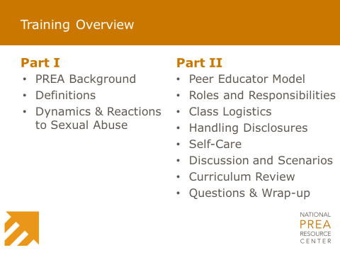 | Let’s review the training agenda to see the different topics that will be covered.  You will notice that this training has two parts.  Explain if you will break the training into two sections or if you will do the training in one sitting.  Ask if the Peer Educator Trainees have any questions.  Briefly review the agenda.  As we go through the training, I will refer to the different slides by the number found at the top of each slide and not by the page number.
Slide 3: Training Guidelines  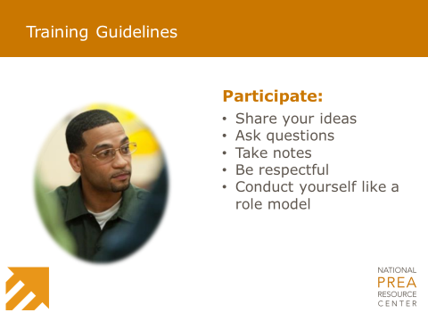 | This training will cover a lot of information. Please ask questions as we go. Chances are, if you have a question, someone else has the same question.  As I have mentioned, I encourage you to take notes.  I also expect everyone to be respectful of each other, what we each have to share, and our beliefs.  What other guidelines should we have as part of this training? I like to think of these as “Ground Rules.”  Allow Peer Educators to share ideas for other Ground Rules. Ask everyone to write them in their notes. Write the Ground Rules on flipchart paper and post to the wall. Ask participants to agree on the Ground Rules.
Slide 4: Part I Cover Slide  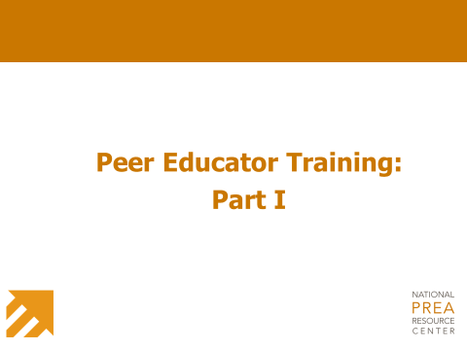 | Before we begin – does anyone have any questions?
Slide 5: Prison Rape Elimination Act  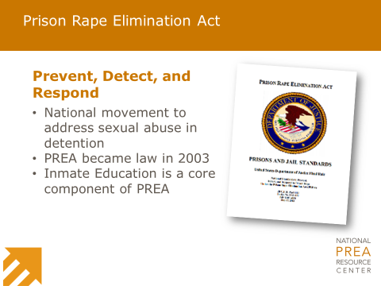 | To start things off, I want to give you a brief history of the Prison Rape Elimination Act, or PREA.  As you can see on slide 5, PREA is federal legislation that was passed in 2003.  The passage of PREA called for the creation of national standards to prevent, detect, respond to, and monitor sexual abuse and sexual harassment in confinement facilities across the nation. There are over 50 standards that this agency/facility has to comply with, inmate education being one of them. We are required to educate all inmates when they first arrive; then, within 30 days, we must give them more detailed information – that is where you come in.  Add information about agency policy for completing the comprehensive PREA education if shorter than 30 days.  As peer educators, you will provide this comprehensive education to your peers. We will talk about why [insert agency/facility name] has decided to use peer education later in the training. Before we move on, I want to note something that I think is important about PREA – its creation and passage was thanks to the hard work of formerly incarcerated survivors of sexual abuse.
Slide 6: Working to Keep Inmates Safe  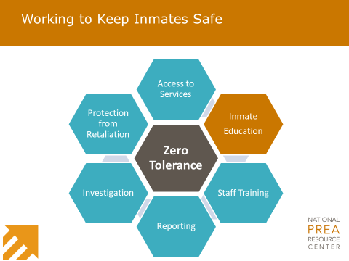 | [Agency/facility name] is committed to PREA and has a zero-tolerance policy for sexual abuse and sexual harassment.  [Agency/facility name] has implemented and continues to work on a variety of PREA implementation efforts. These include:  - Share some of what the agency/facility does in each of the areas listed in the graphic.
Slide 7: Key Terms Defined  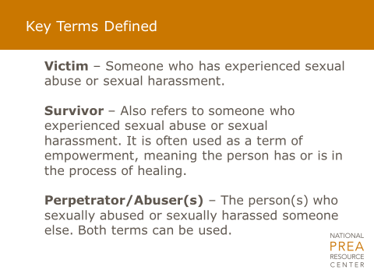 | Throughout this training and in the PREA Peer Education class, we are going to use terms that may be new to some of you.  Is there a volunteer who can read out loud the definitions on slide 7? Allow time for someone to volunteer. If no one volunteers, read them aloud for the group.  Are there any questions about these terms or the definitions? Allow time for people to respond.
Slide 8: What is Consent?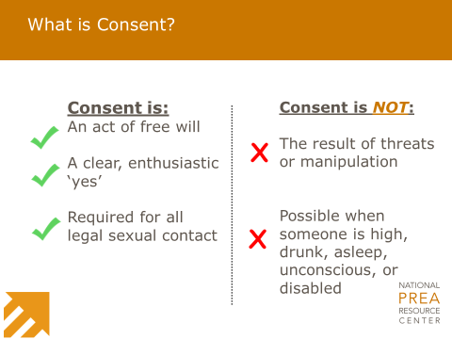 | Another concept is “consent.” What do you think of when you hear this word? Allow time for people to respond.  Thank you for those comments. Let’s look at slide 8 to review what consent is and what consent is not. Review the slide.  It is important to remember that just because consent was given at one point, it does not automatically mean it has been given for all future contact.  A person can always say “no.”  Consent is not: “Well, he didn’t say ‘no’,” or a person saying “I guess so…,” or simply giving in to another person.  What are other examples of consent that are non-sexual in nature?  Allow time for Peer Educators to respond. Some examples to share can include:  - Permission to use another inmate’s belongings.  - Permission to change the TV channel in the common area.  - Asking a parent or guardian to let you borrow something.  - Asking a date if you can kiss them.
Slide 9: Consent in Confinement  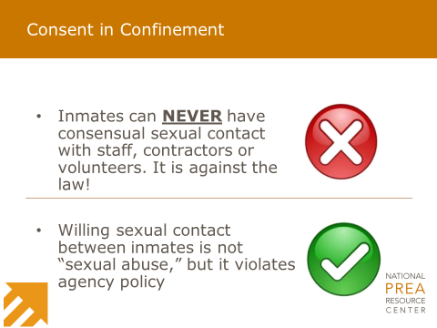 | Slide 9 adds information to what we just explained about consent.  As you can see, inmates can NEVER have consensual sexual contact with any staff, contractor, or volunteer. It is against the law.  Willing, or consensual, sexual contact between two inmates is a policy violation and will result in punishment [insert information about relevant policy violations]. If this is not a policy violation, update content to reflect how the facility deals with consensual sexual contact between two inmates.
Slide 10: Pop Quiz  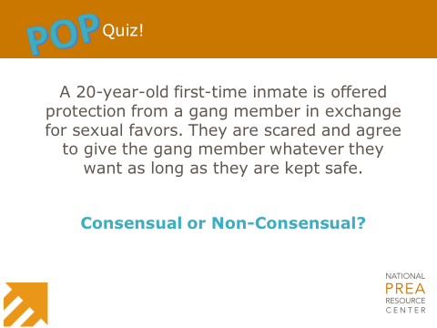 | So, let’s put consent to the test. Read the scenario.  What do you think? Is this consensual or non-consensual? Why or why not? Allow time for people to respond.  This is non-consensual because the inmate performed the sexual favor because they were scared.  They believed that if they did not agree to provide sexual favors their safety would be in jeopardy and they would be harmed.
Slide 11: LGBTI Terminology  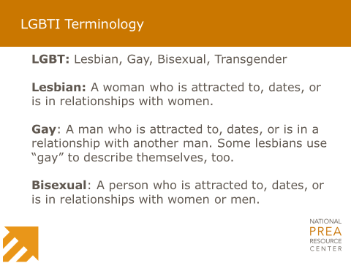 | Let’s review a few more terms. Who knows what “LGBTI” stands for? Allow time for people to respond.  LGBTI stands for “lesbian, gay, bisexual, transgender, and intersex.” Lesbian, gay, and bisexual describe someone’s sexual orientation – that is, who they are attracted to romantically and sexually.  Review the terms on the slide.  A term that is not included on the slide is “straight” – which is also a sexual orientation – and means someone who is attracted to, dates, or is in a romantic relationship with someone of the opposite sex.  In fact, everyone has a sexual orientation.
Slide 12: LGBTI Terminology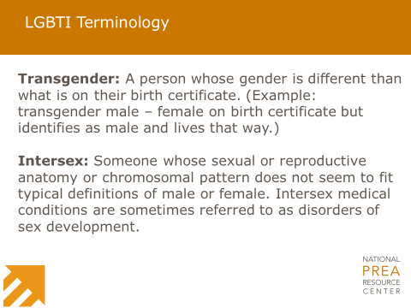 | “Transgender” is another term – an adjective – that describes someone’s gender identity. Like sexual orientation, everyone has a gender identity.  Let’s review the definition for “transgender.” (Review the definition.)  For someone whose gender identity matches what is listed on their birth certificate – we use the adjective “cis-gender.”  In case Peer Educator Trainees ask:  A transgender man is someone whose birth certificate says “female” but who lives as male.  A transgender woman is someone whose birth certificate says “male” but who lives as a female.  There is no specific process someone goes through before they identify as transgender. Someone does not need to have had a certain kind of medical care (hormones, surgery, etc.) before they are a transgender woman or a transgender man.  Let’s look at one last term – intersex. Has anyone heard of this before? Read definition.  Approximately 1 in every 1,500 to 2,000 people are born intersex. There isn’t a single characteristic that defines someone with intersex traits. While some people may have physical characteristics – such as their genitals – that indicate an intersex status, others may go their entire lives without knowing; or they may only find out when they go through puberty and do not develop traditional characteristics for their gender identity, or are unable to reproduce.
Slide 13: Defining Sexual Harassment – Inmate-on-Inmate  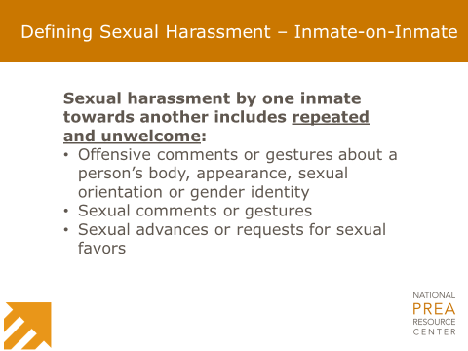 | PREA is about inmate sexual abuse and sexual harassment. We are going to review the definitions for these terms over the next few slides.  As you will see, there are different definitions when staff, contractors, or volunteers commit sexual abuse, as opposed to inmates.  Review definition of “inmate-on-inmate sexual harassment.”  It’s important for inmates to report sexual harassment, even if it is the first time it has occurred. Reporting sexual harassment every time it happens will enable the facility to show how the action is repeated and unwelcome.
Slide 14: Defining Sexual Harassment – Staff-on-Inmate  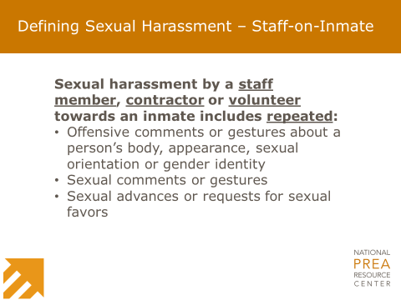 | Now let’s talk about staff-on-inmate sexual harassment. Remember, when we say “staff” this means staff, contractors, and volunteers.  Review definition of “staff-on-inmate sexual harassment.”  You may have noticed that this definition is similar to the one we read before. However, one difference is that gestures or comments from staff, contractors, or volunteers do not have to be unwelcome because residents cannot consent to those actions from staff.  As we have already discussed, inmates need to report any and all sexual harassment by staff, contractors, or volunteers.  This kind of behavior is not only unprofessional, it is also against agency policies.
Slide 15: Defining Sexual Abuse – Inmate-on-Inmate  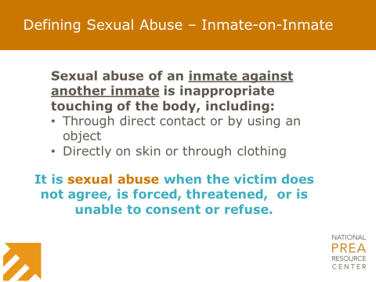 | Now we will turn to definitions for sexual abuse.  Review definition of “inmate-on-inmate sexual abuse.”  Remember what we discussed earlier about consent. Consensual sexual relationships between inmates are against agency policy but are not considered a PREA incident. As mentioned previously, adjust as needed if not a policy violation.  All incidents involving sexual activity will be investigated to make sure it is not sexual abuse.  There may be inmates who are known to be in a consensual relationship. But as we have discussed in this training, what was once consensual can become non-consensual. Imagine a situation where one inmate tries to end the relationship but is forced or coerced to continue with the sexual activity. That IS sexual abuse.  An inmate will not be punished for reporting a relationship that became abusive.  This facility takes all reports of sexual abuse seriously. They will thoroughly investigate all reports. We want to keep all inmates safe.
Slide 16: Defining Sexual Abuse – Staff-on-Inmate 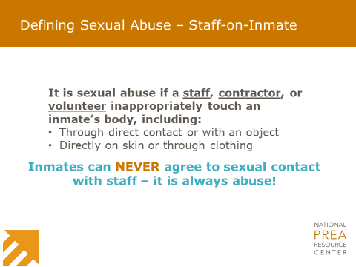 | The definition on slide 16 for “staff-on-inmate sexual abuse” is similar to what we just read for inmate-on-inmate.  Read the definition of “staff-on-inmate sexual abuse.”  The law says that inmates cannot consent to a sexual relationship with staff, contractors, or volunteers because of the authority or power they have over inmates. This kind of relationship is NEVER allowed.
Slide 17: Defining Sexual Abuse – Staff-on-Inmate, cont.  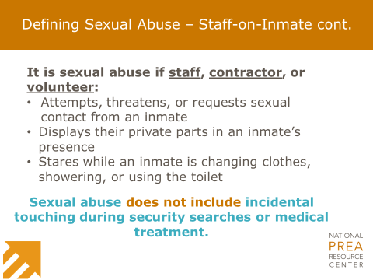 | As you can see on slide 17, the definition of staff-on-inmate sexual abuse is more in-depth.  Review definition of “staff-on-inmate sexual abuse.”  What do you think about the last part of this slide about “incidental touching” during security searches or medical treatment? What do you think this means? Allow time for people to respond.  Staff have been trained on how to properly conduct a pat search which, as you know, includes searching between the legs and across the chest/breast area. No one likes to be searched and staff do not enjoy conducting searches, but it is a necessary part of the job. However, if an inmate feels that any staff conduct searches inappropriately, this needs to be reported to determine if it was sexual abuse.
Slide 18: Defining Sexual Abuse – Staff Voyeurism  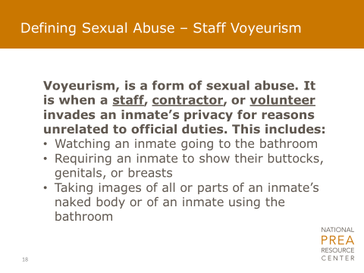 | Who has heard of “voyeurism?” Allow time for people to respond.  Voyeurism means someone gaining sexual pleasure from watching someone else.  Let’s read this definition to see how it applies to PREA. Read definition of “staff voyeurism.”  Voyeurism is a form of sexual abuse.  Keep in mind that staff are required to make security rounds which include looking into cells and monitoring the showers. During these rounds staff may see an inmate naked, but it is only considered voyeurism if the staff person stops and stares at the inmate.  Staff of the opposite gender – i.e., a female going into a male housing unit – are required to announce that they are entering. This allows inmates to cover up so they are not seen in a state of undress when the staff make their rounds.
Slide 19: How Often Does It Happen?  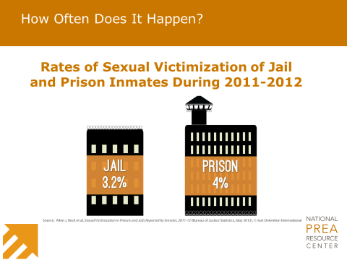 | Before we move on, are there any other questions about the various definitions that we just reviewed? Allow time for people to think of and ask questions.  You may be wondering, with all the attention we pay to PREA, how often does sexual abuse happen?  If you look on slide 19 you will see information about how often it happens. These numbers come from the Bureau of Justice Statistics (or BJS), a federal agency that conducts research and has done surveys of inmates to learn more about how often sexual abuse happens.  These surveys were anonymous.  What do you think when you see these percentages? What do you think this means in terms of actual numbers of people? Allow time for people to respond.  Based on the number of people incarcerated in the U.S. at the time of this survey, these percentages translate into 200,000 people each year being sexually abused in confinement settings.  How does this change your thinking on the percentages? Allow time for people to respond.  Beck, A. J., Berzofsky, M., Caspar, R., & Krebs, C. (2013). Sexual victimization in prisons and jails reported by inmates, 2011–12. Washington, DC: Bureau of Justice Statistics. Retrieved from http://www.bjs.gov/content/pub/pdf/svpjri1112.pdf
Slide 20: What Do You Think?  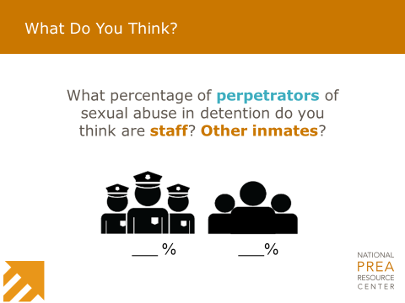 | These national surveys have given us a lot of information about sexual abuse in confinement. One piece of information is about who perpetrates the sexual abuse.  What do you think? What percentage of perpetrators do you think are staff and what percentage are other inmates? Allow time for people to respond.  Nationally, people who reported in the BJS surveys that they have been sexually abused in confinement said the perpetrator was:  - Staff: 52% of the time.  - Another inmate: 48% of the time.  So the numbers are almost equal when it comes to staff and inmates as perpetrators of sexual abuse.  Beck, A. J., Berzofsky, M., Caspar, R., & Krebs, C. (2013). Sexual victimization in prisons and jails reported by inmates, 2011–12. Washington, DC: Bureau of Justice Statistics. Retrieved from http://www.bjs.gov/content/pub/pdf/svpjri1112.pdf
Slide 21: Where Sexual Abuse Takes Place  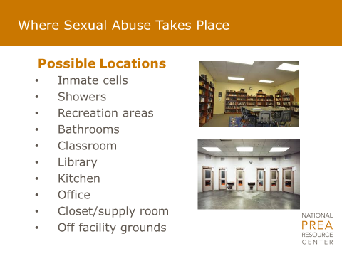 | The surveys also showed us that sexual abuse can occur in many locations throughout the facility. Here is a list of spaces where inmates have reported sexual abuse taking place.  Staff are trained to make security checks throughout the facility, especially in places where there are potential blind spots.
Slide 22: What Do You Think?  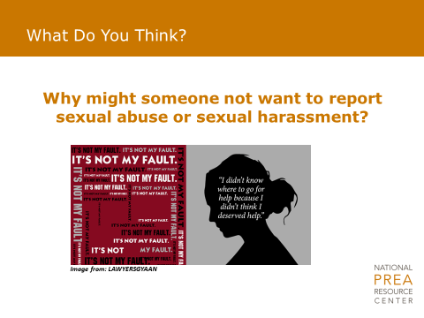 | Why might someone not want to report sexual abuse or sexual harassment? Allow time for people to respond.  Some reasons may include (mention if inmates do not):  - Shame.  - Fear of being retaliated against.  - Fear of additional abuse.  - Embarrassment.  - Fear that everyone will find out what happened.  - Fear that nothing will be done.  Sexual abuse is not the survivor’s fault. It never is.  I have said it before, and I will probably say it again, [insert agency/facility name] takes all reports of sexual abuse seriously and we are committed to getting victims help and keeping them safe.
Slide 23: Dynamics of Sexual Abuse  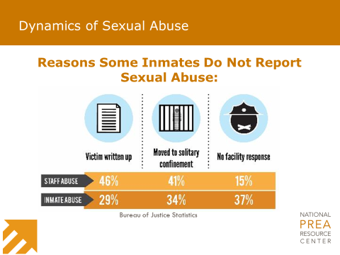 | The surveys also identified reasons why people who were sexually abused chose not to report. Review the information on the slide.  What do you think about this information? Allow time for people to respond.  Beck, A. J., Berzofsky & Johnson, C. (2012). Sexual victimization reported by former state prisoner, 2008. Washington, DC: Bureau of Justice Statistics. Retrieved from https://www.bjs.gov/content/pub/pdf/svrfsp08.pdf
Slide 24: Dynamics of Sexual Abuse  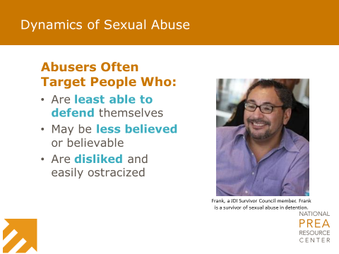 | Slide 24 describes who sexual abusers tend to target for abuse. Review the slide.  Here are some examples of groups that may be perceived to have these characteristics:  - People with a mental illness.  - People who don’t speak English fluently.  - Lesbian, gay, bisexual, transgender (LGBT) people.  - People with a history of making false allegations – thinking that no one will believe them if they accurately report.  Are there other people that you think might be a target for abuse? Allow time for people to respond.
Slide 25: Dynamics of Sexual Abuse  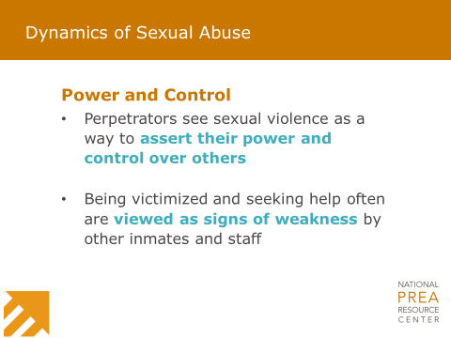 | As I mentioned earlier, sexual abuse is not about love. It is about power and control.  Review the information on the slide.
Slide 26: Dynamics of Sexual Abuse | Sexual abuse is not something people want to talk about – especially if it is something that happened to them.  Remember – it is never the victim’s fault! Never.  It is important to remember that ANY staff at [insert agency/facility name] is willing and able to help ANY inmate who is experiencing sexual abuse or sexual harassment, or who is concerned about their safety in any way.  No one should feel isolated or alone in dealing with sexual abuse or sexual harassment. Staff want to help, and help is available.
Slide 27: Vulnerable Populations  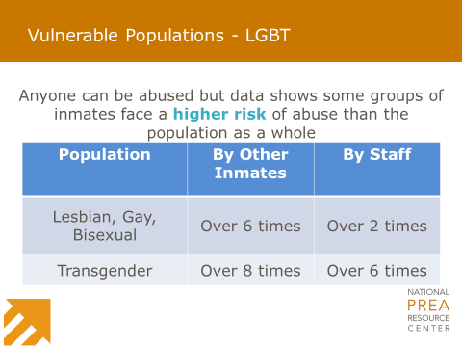 | While anyone could be a victim of sexual abuse or sexual harassment, unfortunately, there are some groups of people that are at higher risk.  [Insert agency/facility name] wants to know who is at higher risk of sexual victimization in order to keep them safe; but we do not single anyone out or isolate anyone as a way to protect them.  Review the information on the slide.  Beck, A. J., Berzofsky, M., Caspar, R., & Krebs, C. (2013). Sexual victimization in prisons and jails reported by inmates, 2011–12. Washington, DC: Bureau of Justice Statistics. Retrieved from http://www.bjs.gov/content/pub/pdf/svpjri1112.pdf
Slide 28: Vulnerable Populations - LGBT  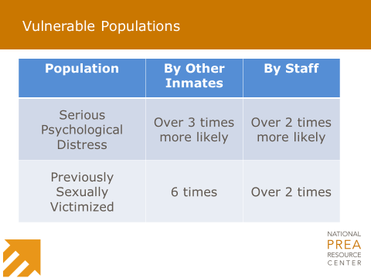 | Review the information on the slide.  Are you surprised by the information on vulnerable populations? Allow time for people to respond.  Beck, A. J., Berzofsky, M., Caspar, R., & Krebs, C. (2013). Sexual victimization in prisons and jails reported by inmates, 2011–12. Washington, DC: Bureau of Justice Statistics. Retrieved from http://www.bjs.gov/content/pub/pdf/svpjri1112.pdf  Beck, A. J.(2014). Sexual victimization in prisons and jails reported by inmates, 2011–12. Supplemental Tables: Prevalence of Sexual Victimization Among Transgender Adult Inmates. Washington, DC: Bureau of Justice Statistics. Retrieved from https://www.bjs.gov/content/pub/pdf/svpjri1112_st.pdf
Slide 29: Reactions to Sexual Abuse  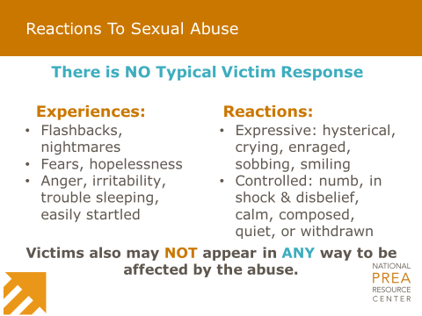 | So how might someone behave if they have been sexually abused? Allow time for people to respond.  You have described a variety of reactions – all of which are possible. In fact, if we look at slide 29, you will see a range of reactions that people might have.  It is important to keep in mind that there is NO one way to react or respond, and in fact, someone might not react in any way that indicates they have been sexually abused.
Slide 30: Impact of Sexual Abuse 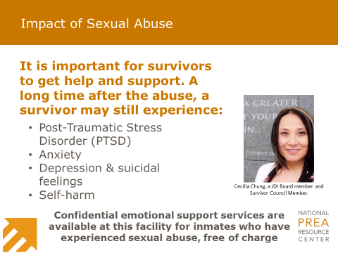 | People may display symptoms of the abuse immediately after it happens. Unfortunately, the impact of abuse does not always go away and some people may be impacted long afterwards.  Review the slide.  Having one of these conditions does not automatically mean a person has been sexually abused. This might be a result of some other experience they have had in their lives.  This facility offers confidential emotional support services through [organization’s name], free of charge, for inmates who have experienced sexual abuse. Inmates can access these services regardless of when the abuse occurred.  This is the end of Part I of your training. We have discussed a lot of information. What questions do you have? Allow time for people to respond.
Slide 31: Part II Cover Slide  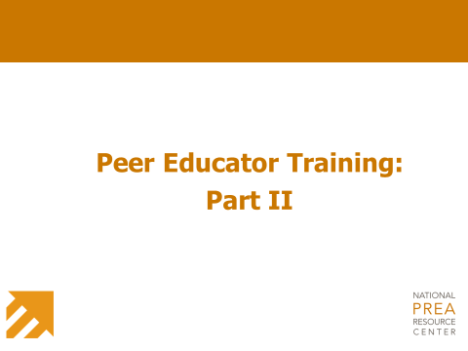 | The transition between Parts I & II is a good place to take a break – either to get lunch or to pause the training to be completed another time.  If the training takes place all in one day, ask if inmates can be counted in the training for all counts. Also, try to have meals delivered to the training room. These two things will help to keep the group together and not delay the training.  Invite current peer educators to participate in Part II (or the entire training). They can add to the discussions about how to handle different comments and situations. Make sure to have them introduce themselves before you begin.  Welcome back – we will now turn to the second part of your training on how to be peer educators. This section will focus on your roles and responsibilities as a peer educator. We will have some scenarios and discussions and will also review the PREA Peer Education class curriculum that you will use to teach your peers.
Slide 32: What Do You Think?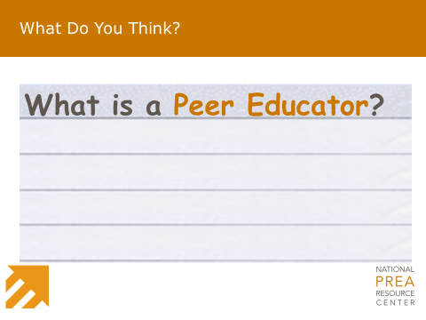 | Let’s look at slide 32. What do you think? What is a Peer Educator? Allow Peer Educators to respond.  Additional ideas once the peer educators have shared:  - Teacher.  - Someone who shares information with others.  - Mentor.  - Role model.  - Trustworthy in the eyes of other inmates and staff.  A peer educator is all of these things. In fact, you might see that your role as a peer educator will not end when you finish a class. Other facilities using peer education have found that inmates see peer educators as leaders at the facility and approach them outside of classes with questions and for support.  We will talk in this part of the training about your role and limitations to helping your fellow inmates.
Slide 33: Faces of Peer Education  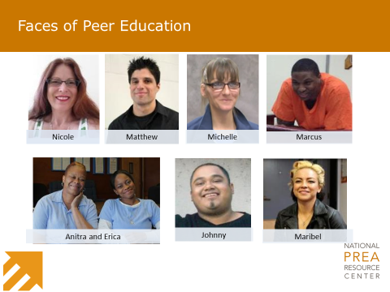 | Peer education is not new, but it is not widely used. Facilities that have implemented peer education have found it to be a useful way to share information with the inmate population.  While no one wants to talk about sexual abuse and sexual harassment, facilities using peer education have found that inmates are a lot more comfortable when they are learning about it from fellow inmates.  Slide 33 shows the photos of some peer educators from across the nation. Peer education programs have taken place in adult prisons and jails, and even in juvenile detention facilities.  When asked about being a peer educator, this is what peer educators had to say:  Choose to read all or some of the following:  Being a peer educator isn’t for selfish people. It’s for someone with a big heart, because this has to be done. You do this program for other people. It’s for everybody else. Do it for them. I know I first started doing it for the money, but I stayed because I saw it was important. People need this information.  Being a peer educator has shown me that I have to hold myself to a higher standard. I want better for myself, and it’s making me want to keep myself out of prison. People watch us and they expect more from us. I want to be a leader.  If you do not know your rights, you do not know if they are being violated or neglected. Recognize your rights and be courageous when they are being violated. Learn how to pay attention to your instincts. You know if something is not right.  If there are current peer educators participating in the training, ask them for their thoughts about what it means to be a peer educator. Also ask them to share what they expected being a peer educator would be like and how that perspective has changed now that they are peer educators.
Slide 34: Peer Education Model  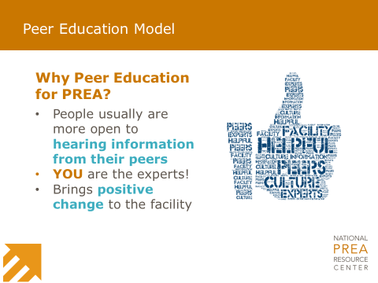 | Peer education programs in adult correctional facilities have helped improve facility culture.  From these programs, we are confident that Peer Education at [insert facility name] will be a great way to strengthen the relationship between staff and inmates.  As someone living at [insert facility name], you understand how things operate from an inmate perspective, which may differ from that of staff. This is not bad, but different.
Slide 35: Peer Educator Position  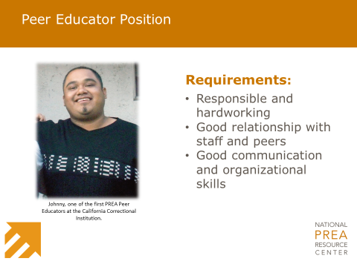 | I am excited to have you be part of this program!  You were each selected to be peer educators because you are interested in the program. You are also hardworking and responsible and have good relationships with staff and your peers.  Throughout your time as a peer educator, I will meet with you to provide feedback on how you are doing. And while you may choose at some point to step down from this position, it is my goal to provide you the support you need to be successful and to grow your skills and abilities serving in this role.  I do have to review behaviors that may require you to be dismissed.  Review the facility/agency disciplinary infractions that will require them to be removed from the program temporarily or permanently.
Slide 36: Peer Educator Responsibilities  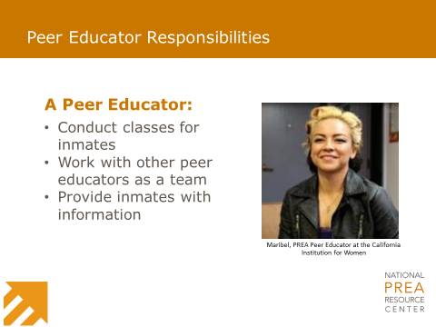 | Beginning on slide 36, let’s review your responsibilities:  You have each been approved to work [insert number of hours] per week as peer educators. We will dedicate that time over the next few weeks to practice teaching and to work together as a team.  If peer education has already started and this is a training for additional peer educators, modify the above text to say: “Before you start to teach, you will spend time observing peer education classes and practicing the class material.”  PREA Peer Education classes will primarily be for new arrivals to [insert facility name]. The number of classes each week will depend on the number of arrivals to the facility.  As time goes on, we will look to expand the program to all inmates. That will certainly require more classes for a period of time until everyone has participated in the program.
Slide 37: Peer Educator Responsibilities  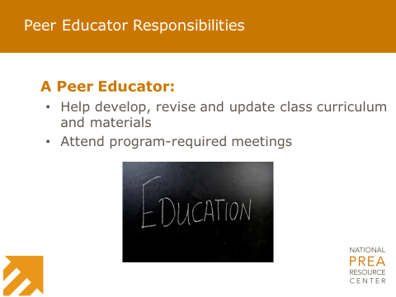 | As a group, we will debrief after the classes to see what went well and what areas need improvement. This will also be a chance to talk about challenging situations and to offer each other advice about what to do.  There are evaluations that you will ask participants to complete at the end of each class. This feedback will also help us to revise the class materials. For example, there are scenarios for the class to discuss. As a group, we may decide that the scenarios are not relevant to [insert facility name] and need to be revised. We will work together to make these changes.  And if [insert facility/agency name] policies change on something we cover in the class, we will make these updates, too.  As I mentioned above, we will also meet one-on-one for more individualized feedback and to check in to see how things are going.  Talking about sexual abuse and sexual harassment, and hearing from others about their experiences, can be stressful and traumatic. It might bring up feelings from your own past or may make you feel upset hearing about others’ experiences.  I want you to stay safe and healthy, too. So each month, you will be offered a check-in about your mental health. This is optional, but an opportunity for you to talk with someone about being a peer educator. We encourage you to attend.  If a community advocacy organization has also agreed to meet with peer educators, include that information here.
Slide 38: Peer Educator Role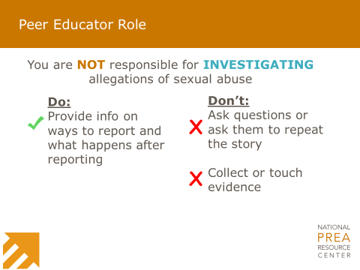 | Turn to slide 38.  As I have mentioned before, as peer educators you will be seen as leaders and as people who can be trusted.  Inmates may come tell you about sexual abuse they have experienced. The next few slides will review what you can do to help them.  If someone tells you they were sexually abused at the facility, you are NOT responsible for reporting sexual abuse. You can tell them about the various ways to report; we will review these when we review the class materials.  It is really important that you do not ask them person questions or ask them to repeat their story of the abuse. You are not an investigator, and even though you just want to help, asking questions and collecting or touching evidence can compromise the investigation.
Slide 39: Peer Educator Role  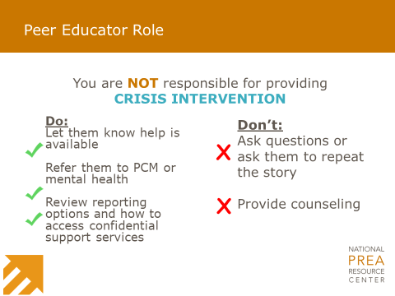 | You are not responsible for being a counselor. In fact, trying to provide counseling to someone can end up being harmful to yourself and to the victim.  Review the slide information about what they can and cannot do.  Are there questions about your role and the limitations we have discussed?
Slide 40: Tips for Co-Leading Class  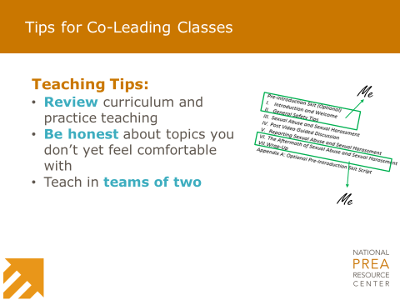 | Let’s shift gears to talk about the PREA Peer Education classes.  You will teach in teams of two. As we practice the material and practice teaching a class, I will observe how you work together and make pairings that I think will be most effective. These could change at some point, or you might need to step in if someone is not available to teach.  As teams, you will work to decide who will teach what portion of the class. Don’t worry about this now.  As you review and become familiar with the class material, I want you to keep in mind parts that you really enjoy teaching or anything you are less comfortable with. I need you to speak up and let me and your teammates know. This will help the team work together better and find a way to balance who teaches what.  Also keep in mind that we will have plenty of time to practice teaching. Some of your initial discomfort might go away the more you practice.  The curriculum I hand out is yours to keep. It is written as a script and you should feel free to use it as such. You can also change it to make it sound more like you – we just need to make sure not to change the meaning of the information in any way.  I think you will find that the more you practice, and as you begin to teach, you will become more comfortable with the information and will also find you are memorizing parts of it.  As we work together, I want you to think creatively about how to present the information. For example, one group of peer educators used flip chart paper to write down key points from the class. These were visuals for the class to read and reminders to the peer educators about critical information to review. If you have ideas, tell me and we’ll see what we can do.  Ask current peer educators to share ways they have adapted the materials.
Slide 41: Tips for Co-Leading Class  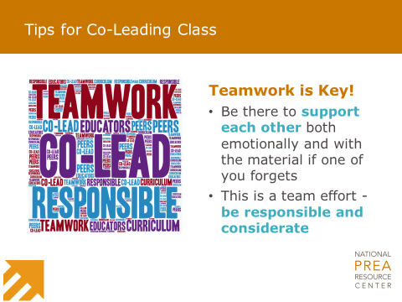 | Some of you might know each other, but as we continue to work together I want us to become a team.  Supporting each other will be important to our success. This may mean stepping in if your partner forgets some information during a class, or providing support to deal with difficult class situations.  I am excited to work with you and to watch you grow into the role of peer educator.  If there are other staff who will be supporting the program, introduce them if they are not at the training.
Slide 42: Classroom Logistics  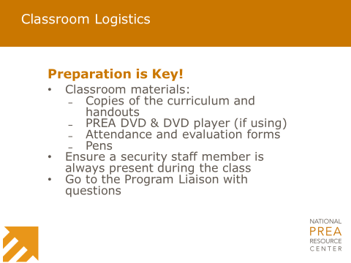 | Being organized will help the classes run smoothly.  Review the slide and go over where classes will take place and where class materials will be stored (or who will provide them before the class). Use this time to review any other logistics such as attendance and what to do with the class evaluations.
Slide 43: Communication Tips  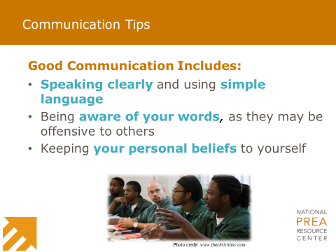 | Slides 43 and 44 focus on communication tips. I want to review these slides as they give an overview of the kind of feedback you can expect us to give one another as you practice teaching and when you are teaching a class.  Speak to the class as you would to people in your housing unit. Keep in mind that, as peer educators, you are committing yourselves to educating all inmates about their rights and about how to get help.  We all have our beliefs, but you cannot let those interfere with the class or how you treat the inmates in the class.
Slide 44: Communication Tips  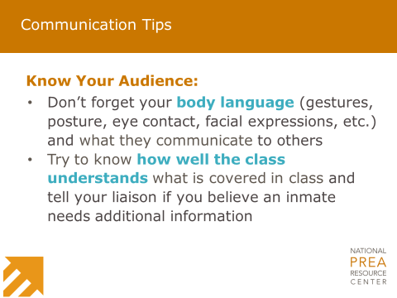 | It is not just what you say that impacts your ability to interact with people.  While you may say one thing, your body language may tell a different story.  Can someone give me examples of what I mean by body language? Allow time for people to respond. Add any of the following to what is shared.  That’s right. Things like posture, eye contact, gestures, and facial expressions are very telling about how we really feel – no matter what we say.  As peer educators, effective body language (walking around, hand gestures, expressions, etc.) can help engage the class . Just make sure it is respectful and appropriate.  We will practice how to respond in some scenarios later in this training. But some tips for talking with someone include:  - Using active listening skills such as:  - Keeping eye contact.  - Nodding and using small verbal comments like “yes” and “okay” to confirm you are listening.  - Being mindful of your body language including gestures, posture, rolling eyes, and facial expressions.  Ask participants to model some of these behaviors.  In addition to communicating effectively, it is important to observe the people in the class to see if they are understanding the information. Are people engaged? Do they look confused? Are they talking?  If you notice someone in your class isn’t understanding the material, tell me so I can follow-up with them. However, be sensitive not to single anyone out during class. Someone might have difficulty hearing or seeing, they may have trouble staying focused, or English might not be their first language. It is not your responsibility to figure out why they may not be understanding. However, if you notice that they are struggling in some way, it is important that you let me know.
Slide 45: Handling Disclosures  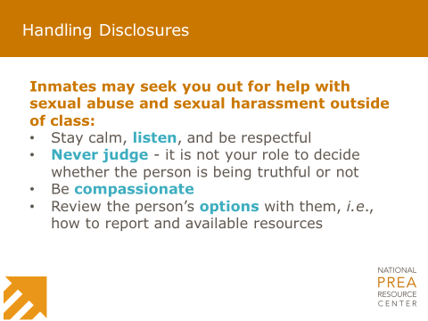 | As peer educators, it is not a matter of if, but when, someone will disclose to you an incident of sexual abuse or sexual harassment from some point in their lives.  The advice on slide 45 applies regardless of any personal relationship you may have with this person asking you for help.  It is natural to feel like you aren’t doing enough in this type of situation, but validating someone’s feelings, believing them, and providing them with information and referrals is helpful.  If an inmate approaches you seeking counseling services, you can validate their feelings by letting them know that you are sorry for what has happened to them, and then direct them to mental health or [insert confidential support services information].  You will be seen as someone that others can come to for advice and support. It will be important to let those who come to you know that you are not a counselor, but can provide information about how to get that kind of help and support.  You are going to learn personal information about people. Keeping this information private is critical. If someone discloses sexual abuse or sexual harassment to you, they trust you. Telling your friends or even fellow peer educators will erode this trust and will put the program in jeopardy.  If you ever feel that someone is in immediate harm from an abuser, is a danger to themselves (suicidal), or may harm someone else, please tell me or another staff member immediately so we can provide crucial help to those in need.  What reactions do you have after reading this slide?  Allow time for people to reflect and share their ideas. If current peer educators are in the training, ask if anyone wants to share a time when someone told the rest of the group about being sexually abused and how they handled it. Be sure to remind them not to share any names or identifying details. It is more important to talk about how the peer educator handled the situation than to focus on the details of the disclosure.
Slide 46: Self-Care  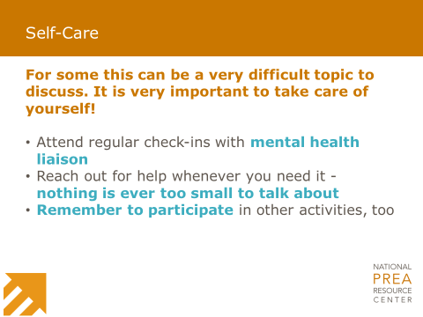 | [Insert facility name] wants you to be successful as peer educators. Being healthy – both physically and mentally – is key to that success, and to success as a human being. Asking for help takes courage and demonstrates a desire to be healthy.  I mentioned that I will arrange monthly check-in meetings for each of you with mental health [insert community advocate information if applicable].  Even if you don’t feel like you need to meet with someone, it is an opportunity for you to discuss how the classes are going or to talk about any other issues you may be going through unrelated to the peer education program.  Also know that you do not need to wait for your monthly check-in to talk with someone. If you need to talk to someone, just ask and I can help you arrange a meeting with mental health [and/or community advocate].  Now is a good time to take a short break in the training. A lot of intense information has been discussed and it is important for peer educators to take a break to refresh.
Slide 47: What Would You Do?  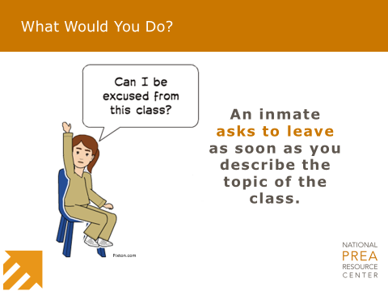 | Even though you have not yet taught a class, I want us to spend time thinking about how to respond in different situations. I will read the scenario and want you to take a few minutes to think about and write down how you would respond. I will ask for volunteers to share.  Read the scenario and give time for people to write their notes. Ask for volunteers to share their ideas of how to respond. Share any ideas from the list that they do not suggest. Ask any current peer educators for their ideas.  - Tell the inmate that the information they receive could help them or someone they care about one day.  - Tell them the class is required and they will have to receive it on another day if not today.  - If they continue to insist on leaving, let a staff member handle the situation.
Slide 48: What Would You Do?  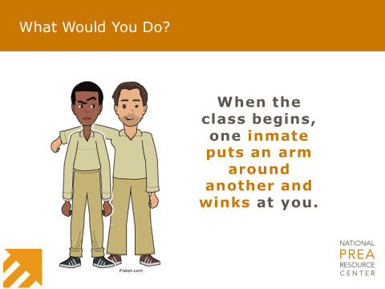 | Great – let’s try another one.  Read the scenario and give time for people to write their notes. Ask for volunteers to share their ideas of how to respond. Share any ideas from the list that they do not suggest. Ask any current peer educators for their ideas.  - Inform them that sexual abuse is not a joke, and they could be offending someone in the room.  - Let them know you understand that the material may be uncomfortable. Ask that they sit silently and act respectfully until it is over.  - If they become too much of a distraction for the class, let the staff member handle the situation.
Slide 49: What Would You Do?  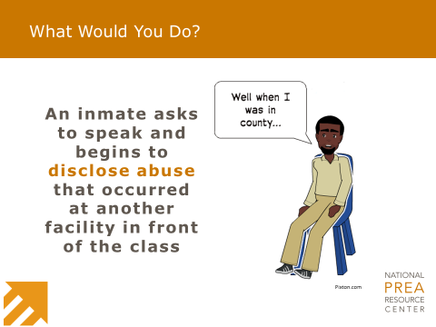 | Let’s do one more class-focused scenario.  Read the scenario and give time for people to write their notes. Ask for volunteers to share their ideas of how to respond. Share any ideas from the list that they do not suggest. Ask any current peer educators for their ideas.  - Be compassionate and empathetic.  - Thank them for sharing.  - Remind them of the ways they can report sexual abuse or sexual harassment.  - Ask them to meet you after class so you can give them information on reporting.
Slide 50: Scenario #1  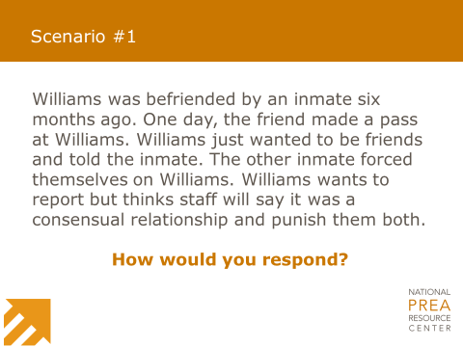 | Great job! I am sure that as we begin to have classes, other situations will come up that you will have to handle in the moment. Remember that you will have a partner there to help you respond, and there will always be a staff person nearby to help.  Now we are going to look at some additional scenarios to discuss how best to respond. I will read the scenario and will give you time to write down how you would respond before asking volunteers to share.  Read the scenario and give time for people to write their notes. Ask volunteers to share their ideas on how to respond. Share any ideas from the list that they do not suggest. Ask any current peer educators for their ideas.  - Stay calm and validate Williams’ feelings.  - Let Williams know that what the inmate did is sexually abusive and is illegal. Williams cannot get into trouble for reporting an incident of sexual abuse.  - Inform William of all the ways to report and what their options and rights are (the right to report and the right to be free from sexual abuse and retaliation).  - Tell Williams how [insert facility/agency name] will provide necessary medical and mental healthcare.  - Give Williams information on how to reach someone to talk to about the sexual abuse – either mental health or a victim advocate.
Slide 51: Scenario #2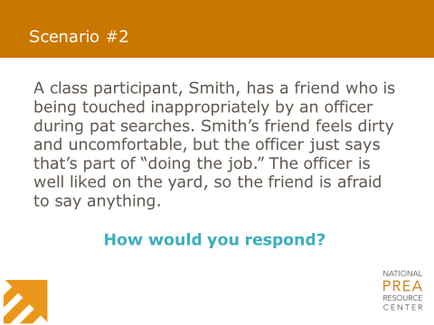 | Great – let’s try another scenario.  Read the scenario and give time for people to write their notes. Ask volunteers to share their ideas on how to respond. Share any ideas from the list that they do not suggest. Ask any current peer educators for their ideas.  - Thank Smith for sharing a real-world experience.  - Let Smith know that they can give all the information from the class to their friend.  - Offer to speak with them one-on-one after class to make sure they have all the information to give their friend.  - Use Smith’s story as an opportunity to talk about what options are available to someone going through abuse.  - Remember: There will be a staff member present during each class. They can also help when situations like this arise.
Slide 52: Scenario #3  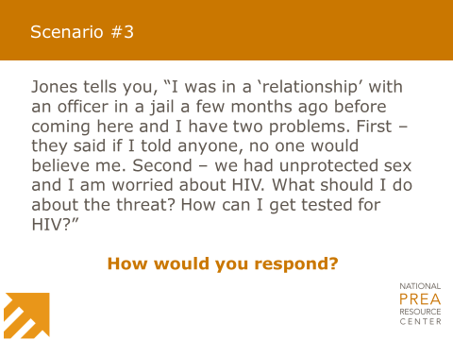 | Last one.  Read the scenario and give time for people to write their notes. Ask volunteers to share their ideas on how to respond. Share any ideas from the list that they do not suggest. Ask any current peer educators for their ideas.  - Stay calm and validate Jones’ feelings. If Jones is afraid, say, “That makes sense,” and, “I understand.”  - Tell Jones you think they deserve to get the help they want/need.  - Explain that residents can never consent to sex with staff, contractors, or volunteers (even if it feels like a relationship).  - Tell Jones they can get an HIV test without providing a reason.  - Tell Jones they can report the abuse to [insert agency/facility name] and [insert facility name] officials who will report it to the jail where the abuse occurred.  - Tell Jones they can get medical or mental healthcare even without reporting the sexual abuse.
Slide 53: Curriculum Review | The last part of the training is to review the class curriculum you will use to teach the PREA Peer Education class.  I will now hand each of you a copy of the curriculum. This is yours to keep. Please put your name on the top.  If you have experienced peer educators helping with the class, ask them to “teach” the new peer educators. Otherwise ask for volunteers to read sections aloud.  It is important to go through the entire curriculum for peer educators to begin to get comfortable with the information.  The video “PREA: What You Need to Know” can be used as part of the class curriculum. Even if it is not going to be used as part of the regular class, the video can be used to reinforce concepts covered in Part I of this training.
Slide 54: Questions?  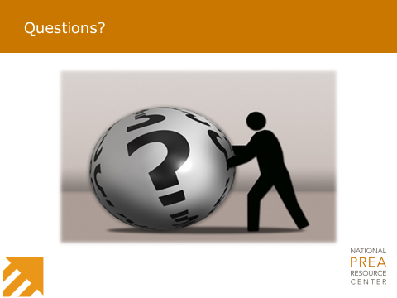 | I want to thank everyone for their participation in this training. You have successfully completed the training and are now peer educators. Congratulations!  It is recommended to have certificates printed in advance to hand out at the end of the training.  The next step is to practice teaching. We will do that [insert date/time, location, and any other logistical information].  In the meantime, please contact me if you have any questions.

