Agency/Facility Name
PREA REFRESHER: Prisons and Jails
Inmate Support Services

Inmate Support Services
This agency has partnered with [advocacy organization name] to provide free, confidential support services to inmates who have experienced sexual abuse (in confinement or at any time in their lives). Inmates can access these services by:
- Dialing [insert number] on any inmate phone
- Writing to the organization at [insert address]

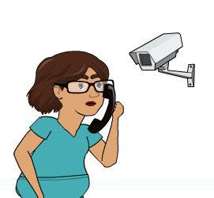
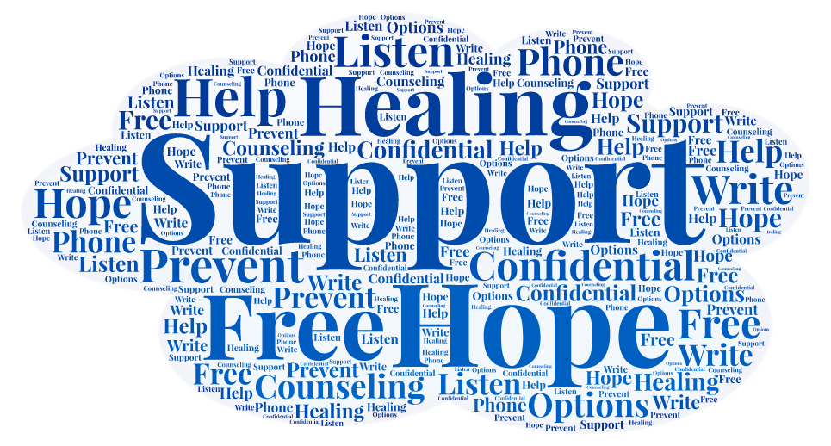
Privacy
Calls to community advocates are not monitored or recorded. This is to ensure that the communications take place in as confidential a manner as possible. As with any other call, there is a 15-minute limit.

Advocates will explain to inmates that most calls will be confidential, but that they will notify the facility if an inmate is being inappropriate or says they plan to hurt themselves, someone else, or plans to escape the facility. [Insert other limits to confidentiality or mandatory reporting].
What Services Are Provided?
[Advocacy organization name] advocates can provide:
- Crisis intervention
- Information about reporting sexual abuse and sexual harassment
- Follow-up support
- Referrals for services post-release
Pixton.com

