Agency/Facility Name
PREA REFRESHER: Prisons and Jails
Ways Inmates Can Report
Multiple Ways Inmates Can Report
Inmates can report sexual abuse, sexual harassment, fear of being abused or harassed, or retaliation in the facility by:
- Telling any staff member, volunteer, or contractor (including chaplains, medical, mental health, or counseling staff)
- Submitting an inmate grievance or just handing a note to staff
- Dialing [number]
- external agency that can receive reports
Pixton.com
Note: Inmates are allowed to report anonymously via phone or external option

Third-Party Reporting
Inmates can also ask someone else to report for them, like a family member, friend, attorney, outside advocate, or another inmate.

This person, known as a third-party reporter, can report on an inmate’s behalf using any of the methods above or by:
- Calling the agency directly
- Contacting the PREA Coordinator (information on the agency website)

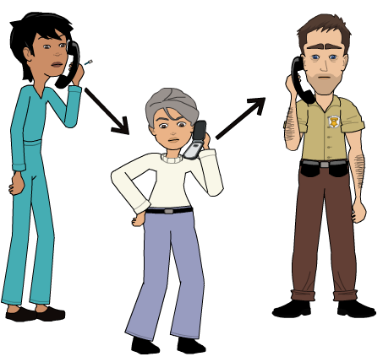

Pixton.com
Reporting from Segregation
Inmates housed in segregation can report to staff or in writing, including through emergency grievances or by calling [number] when they have phone privileges or have received staff permission to use the phone. Staff should respect inmate privacy in such situations.
ICE Detainees
Immigration detainees being held on behalf of the U.S. Immigration and Customs Enforcement (ICE) must be provided with the contact information of their Consulate officials and the U.S. Department of Homeland Security.

