Agency/Facility Name
PREA REFRESHER: Prisons and Jails
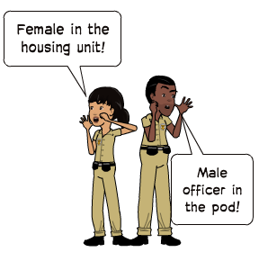
Inmate Privacy
Pat and Strip Searches
Searches are necessary to ensure facility safety and security. Searches can be traumatizing and need to be done professionally and respectfully.
  - Conduct pat and strip searches consistent with agency policy and procedure — variations in search practices cause confusion and distress for inmates
  - Know agency procedures for searching transgender inmates
  - Explain what you are doing during a search, especially if the inmate shows signs of distress
- Do not joke or make off-topic comments during searches
NOTE: You must make an announcement each time you enter an opposite gender unit only when there are no other staff members of your gender present.

Pixton.com
- Use clear, professional language
- Speak loudly enough so you can be heard over noise and conversations
- Be respectful during sleeping hours so as not to wake up inmates

Housing Unit Announcements
Staff must announce their presence when entering an opposite gender housing unit. Announcing gives inmates the opportunity to dress or cover themselves and maintain reasonable privacy.
Please keep in mind that you should:

Reasonable Privacy Does Not Compromise Security
- Inmates must be able to shower, change clothes, and use the toilet without opposite gender staff viewing them (except during routine security checks)
- Avoid staring while inmates are fully or partially undressed

