Agency/Facility Name
PREA REFRESHER: Prisons and Jails
Professional Communication and Boundaries
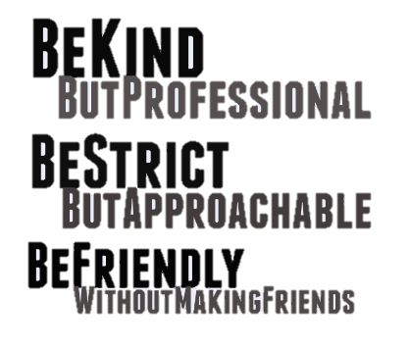
Professional Communication
When staff treat inmates respectfully, inmates will ask for help when needed. Staff should aim to communicate with inmates in a manner that is open, honest, and professional. Here are some tips to achieve an appropriate balance:
- Avoid slang
- Always use respectful language when speaking with inmates and to one another
- Address all inmates using their last name to avoid misusing pronouns
- Never use offensive terms when referring to LGBTI inmates
Appropriate Interactions
Staff can avoid inappropriate behavior while still maintaining open communication with inmates by:
- Allowing small talk but stopping it if it becomes personal
- Enforcing policies in a way that conveys respect and compassion
- Actively listening to inmates but letting them know you have duties to fulfill

Pixton.com
Compromised Professionalism
Developing personal relationships with certain inmates leads to:
- A lack of trust among staff
- Diminished facility safety, including more abuse and harassment
- More power for favored inmates

