**Agency/Facility Name**

**PREA REFRESHER: Prisons and Jails**

**Handling Disclosures of Abuse**

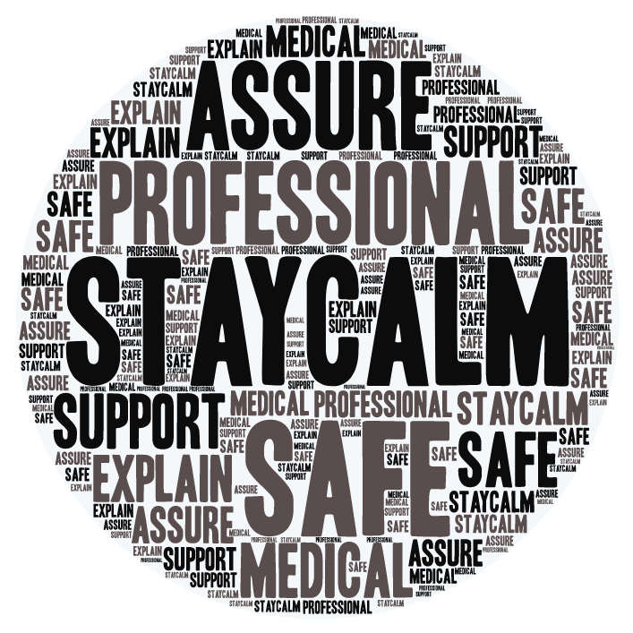

**Disclosures**

An inmate can report to any staff, volunteer, or contractor. It is your duty to handle a report with sensitivity and compassion. Make sure to:

* Stay calm and professional, and let the victimized inmate know that you take this issue very seriously
* Explain the steps this facility will take to keep them safe from the alleged abuser going forward
* Assure them that they will be offered immediate medical care and support

**Common Reactions to Abuse**

There is no “right” way for a person to respond after being victimized; common reactions to trauma vary greatly, but often include:

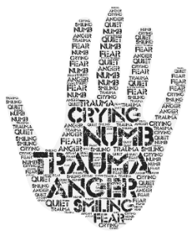

Victims may experience

* Flashbacks, nightmares, anxiety
* Fear, hopelessness
* Anger, irritability, hyper vigilance
* Post-Traumatic Stress Disorder (PTSD)
* Depression and suicidal feelings

Victims may appear

* Expressive: crying, enraged, smiling
* Controlled: numb, in shock, composed, quiet



**Responding to Victimized Inmates**

When talking to an inmate who has been sexually abused, remember:

* They may need time to establish trust or may prefer to speak with someone they already trust
* Their story may seem inconsistent or illogical due to trauma; this does not mean they are lying
* Unless you are an investigator, stick to basic questions like: (1) “Are you injured?” (2) “Are you or someone else in immediate danger?”

Pixton.com