Agency/Facility Name
PREA Refresher: Prisons and Jails
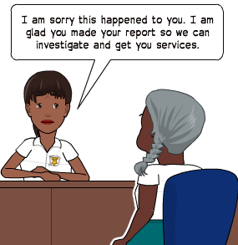
Encouraging Inmates to Report Sexual Abuse
Reporting Improves Facility Safety
If an inmate has been sexually abused or harassed, this facility wants to know so we can keep the inmate safe and provide them the necessary support and resources.

Unfortunately, sexual abuse is underreported and this agency wants to change that.

Pixton.com
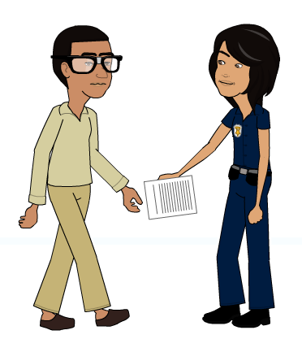
As staff, your role is NOT to determine the validity of a PREA report. You should always:
- Take ALL reports seriously
- Respond immediately following agency response protocols
- Tell a supervisor

Pixton.com
Remember – Treat all reports of sexual abuse or sexual harassment as credible. All reports will be thoroughly investigated and inmates will be protected from retaliation. Where the inmate is acting in good faith and with a reasonable belief that the abuse occurred, discipline is not appropriate.

False PREA reports happen.
But why?
- To seek protection from bullying or physical threats
- To get staff or inmates in trouble
- To attempt to get basic needs met (medical care, hygiene items, etc.)

Consequences for misusing PREA
- Inmates can receive an institutional charge if a report is submitted in bad faith
- A finding of “unsubstantiated” or “unfounded” does not mean the inmate is lying or the report is false

