**Agency/Facility Name**

**PREA REFRESHER: Prisons and Jails**

**Completing a PREA Incident Report**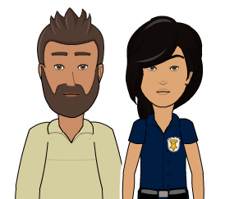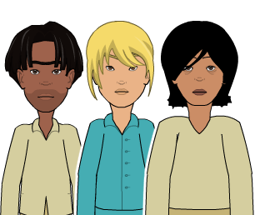

People and Behaviors

* Who is the victim? Perpetrator(s)?
* What was said? Use quotation marks for exact comments.
* What was their behavior?
* Were there witnesses?
* What officer, medical staff, or investigator did you turn the victim over to?

**PREA Incident Reports**

Immediately after completing your first responder duties, complete a PREA incident report. At the very least, your report should include:

Pixton.com



Pixton.com

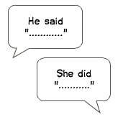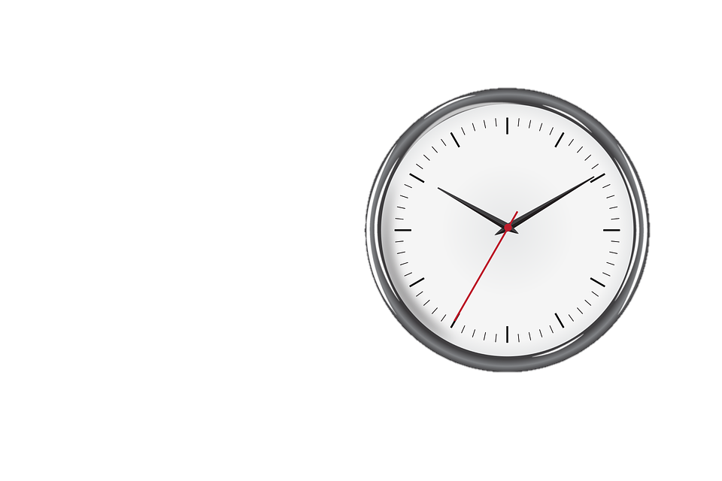

Pixton.com

Pixton.com

Circumstances

* At what time did it take place?
* Was there more than one crime scene?
* Was anything out of place?
* Was there clothing or bedding at the scene?
* Were there suspicious items or fluids?

**Do Not Investigate**

Remember, you are not the investigator and do not need to ask the inmate(s) and/or staff member(s) invasive questions. Your report should mostly include:

* Your observations of facts
* Any thoughts you have (clearly marked by writing something such as, “I think…”)
* Any answers the victim gives to key questions (such as, “Are you injured?” or “Do you believe that you or someone else is in immediate danger?”)