Agency/Facility Name
PREA REFRESHER: Prisons and Jails
PREA Basics

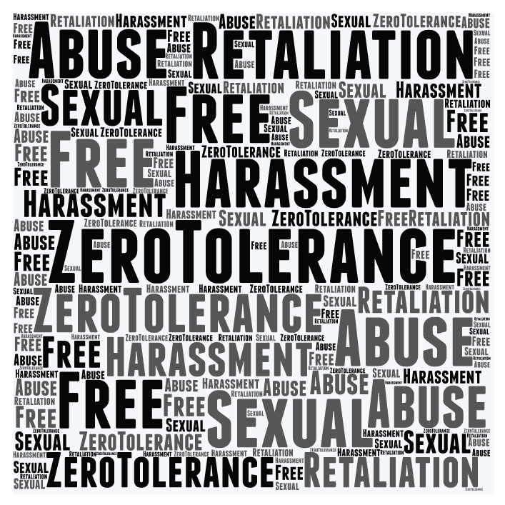

Zero Tolerance Policy
Inmates have a right to:
- Be free from sexual abuse and sexual harassment
- Report and get help if they are abused or harassed
- Be protected from retaliation if they report abuse or harassment, or cooperate in an investigation

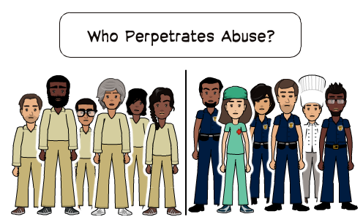
Dynamics of Sexual Abuse in Detention
National surveys conducted by the federal government show that:
- Sexual abuse in detention is almost equally perpetrated by staff and inmates
- While anyone can be targeted, inmates who have a mental illness, have been sexually abused previously, or are LGBT are at higher risk of victimization

- Refusing to leave or return to their cell
- Avoiding — or clinging to — certain inmates or staff
- Acting out or keeping to themselves
- Refusing to shower or showering more frequently
Detecting Signs of Sexual Abuse
Look for changes in behavior, like inmates who start:
Pixton.com
Inmates
Staff

Note: Check on any inmate who exhibits any of these signs. Remember that these may be an indication of trauma or emotional distress unrelated to sexual abuse; some inmates who have been sexually abused may not show any of these signs.

