**Agency/Facility Name**

**PREA REFRESHER: Juvenile Detention**

**Monitoring for Safety and Security**

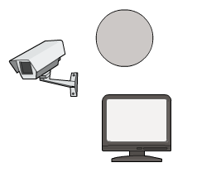

**Tools of the Trade**

This facility uses cameras and mirrors to assist staff in monitoring resident movement. Staff must report to their supervisor and document in unit log books any problems, such as:

* Cameras or monitors that are out of order
* Mirrors or cameras that are not angled correctly to provide clear lines of sight

Pixton.com

**Blind Spots**

Blind spots are areas in the facility that staff cannot easily monitor.

Always try to view the facility with fresh eyes and think about which areas are problematic. Have another staff stand in suspected blind spots and check whether they can be seen from the control booth via camera or during routine security checks.

Blind spots require additional staff monitoring — beyond typical security rounds — to ensure facility safety.

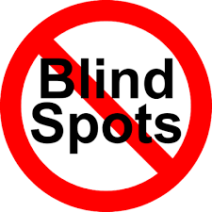

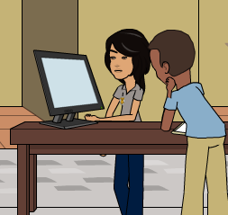

**Resident Movement**

Staff must ensure that residents do not enter areas where they can’t be kept safe.

Residents should not be allowed to linger around camera monitors or other security monitoring technology.

Pixton.com