Agency/Facility Name
PREA Refresher
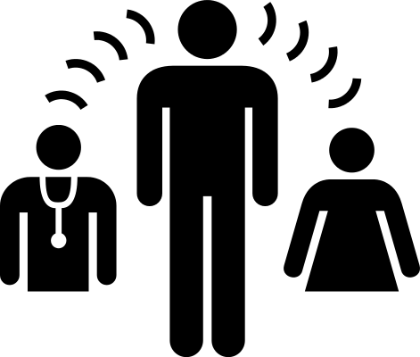
Helping Residents Who Primarily Speak Another Language
Tips for Speaking with Residents Who Do Not Speak English Well
- Use simple language and repeat important points
- Do not interrupt a resident who is trying their best to express themselves in English
- Avoid jargon and idiomatic expressions (examples: “messing with you,” “keep it on the down-low,” “being shady,” “SOP,” etc.)

Can a Resident Provide Interpretation?
- Yes, but only if the person requiring interpretation is in danger or otherwise in immediate need of assistance (examples: during an evacuation or in the immediate aftermath of an assault)
- If you ask a resident to interpret, fill out an incident report explaining why
- Once the danger has passed, ask a supervisor to help you arrange for an interpreter who is not a resident

Who Can Provide Interpretation?
- Facility staff can access [translation service name] which provides translation for most world languages (ask your supervisor about using this service)
- Some staff speak more than one language. It is okay to ask one of them to interpret if they feel comfortable doing so and it has been approved by [title of who approves]

