Agency/Facility Name
PREA REFRESHER: Juvenile Detention
Resident Support Services

Resident Support Services
This agency has partnered with [advocacy organization name] to provide free, confidential support services to residents who have experienced sexual abuse (in confinement or at any time in their lives). Residents can access these services by:
- Dialing [insert number] on any resident phone
- Writing to the organization at [insert address]

What Services Are Provided?
[Advocacy organization name] advocates can provide:
- Crisis intervention
- Information about reporting sexual abuse and sexual harassment
- Follow-up support
- Referrals for services post-release
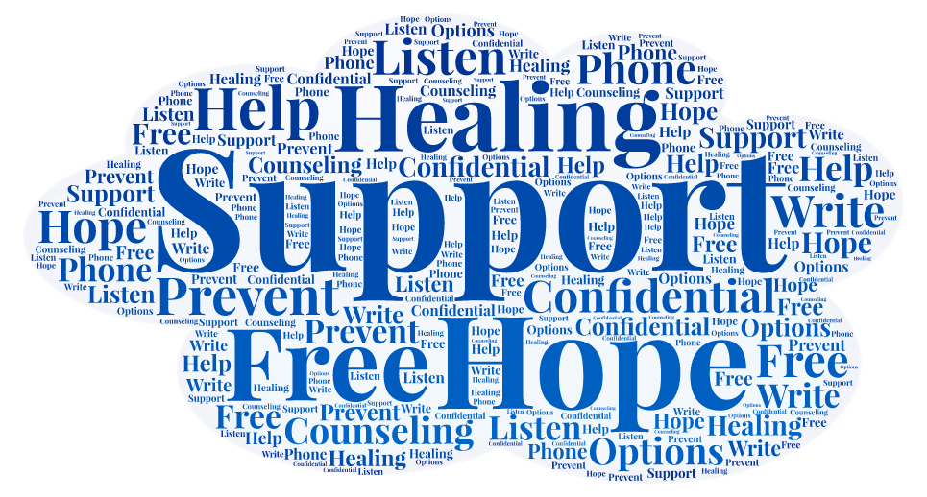
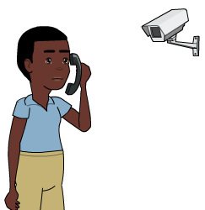
Privacy
Calls to community advocates are not monitored or recorded. This is to ensure that the communications take place in as confidential a manner as possible. As with any other call, there is a 15-minute limit.

Advocates will explain to residents that most calls will be confidential, but that they will notify the facility if a resident is being inappropriate or says they plan to hurt themselves, someone else, or are considering to escape the facility, [insert other limits to confidentiality or mandatory reporting].
Pixton.com

