Agency/Facility Name
PREA REFRESHER: Juvenile Detention
Ways Residents Can Report
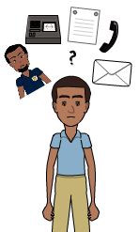
NOTE: | - Staff are mandatory reporters  - Residents are allowed to report anonymously  - Residents on any kind of confinement or segregation status have to be provided the same options as all other residents

Multiple Ways Residents Can Report
If a resident experiences or fears sexual abuse, sexual harassment, or retaliation, they can:
- Tell any staff member, contractor, or volunteer (including teachers, chaplains, medical, etc.)
- Submit a grievance or medical slip
- Ask to speak to the PREA Compliance Manager
- Call/write the [external agency that can receive a report]
Pixton.com
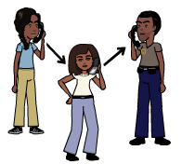
Third-Party Reporting
Residents can also ask someone else to help them, such as a family member, friend, attorney, probation officer, outside advocate, caseworker, foster family, or another resident.

If you receive a request for help from a third party, you must act on it just like you would a request directly from an affected resident.

External Reporting
Residents can contact [organization name] to report sexual abuse or sexual harassment. [Organization name] is not part of the agency and has agreed to accept resident reports. When they receive a report, they will forward the report to the agency to initiate an investigation.
Pixton.com

