Agency/Facility Name
PREA REFRESHER: Juvenile Detention
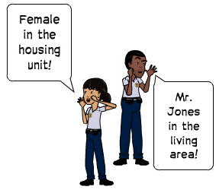
Resident Privacy
* Except in exigent circumstances

Pat and Strip Searches
Searches help ensure facility safety and security. Searches can be traumatizing and need to be done professionally and respectfully.

- Conduct pat and strip searches consistent agency policy and procedures — variations in search practices cause confusion and distress for residents
- Know agency procedures for searching transgender residents
- Only pat and strip search residents of the same gender*
- Explain what you are doing during searches, especially if there are signs of resident distress
- Do not joke or make off-topic comments during searches
NOTE: You must make an announcement each time you enter an opposite gender housing unit only when there are no other staff members of your gender present.

Please keep in mind that you should:
- Use clear, professional language
- Speak loudly enough so you can be heard over noise and conversations
- Be respectful during sleeping hours so as not to wake up residents

Pixton.com
Housing Unit Announcements
Announcing the presence of opposite gender staff gives residents the opportunity to dress or cover themselves and maintain reasonable privacy.

Reasonable Privacy Does Not Compromise Security
A key part of your job is keeping residents and staff at our facility safe. While limits on residents’ privacy are a given, residents need a reasonable level of privacy to feel safe when they are showering, using the bathroom, or changing clothes. Balancing security and privacy is crucial to fostering a safe community for youth in detention.

