Agency/Facility Name
PREA REFRESHER: Juvenile Detention
Professional Communication and Boundaries
Professional Communication
When staff treat residents respectfully, residents will ask for help when needed. Staff should aim to communicate with residents in a manner that is open, honest, and professional. Here are some tips to achieve an appropriate balance:
- Avoid slang
- Always use respectful language when speaking with residents and to one another
- Model the language and behaviors you want residents to use
- Address all residents using their last name or preferred first name to avoid misusing pronouns
- Never use offensive terms when referring to LGBTQ residents
Intervene and Redirect
Step in when peers aren’t maintaining boundaries. Crossing a boundary can include:
- Gossiping with residents about others in the facility or sharing personal information
- Using inappropriate language or discussing inappropriate topics with residents
- Providing certain residents special privileges or unearned incentives

Pixton.com
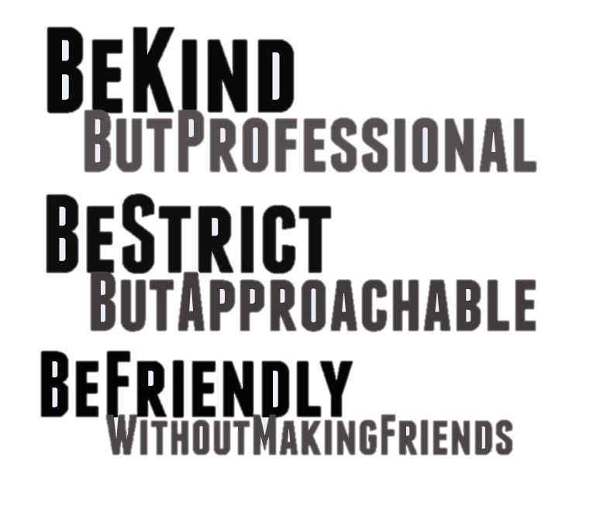
When Staff Fail to Show Professionalism
Interacting inappropriately with residents leads to:
- Increased distrust among staff
- Diminished facility safety, including more abuse and harassment
- More power for favored residents

