**Agency/Facility Name**

**PREA REFRESHER: Juvenile Detention**

**Handling Disclosures of Abuse**

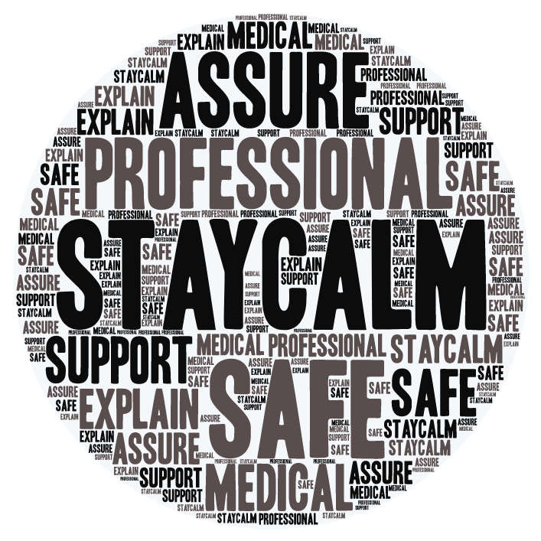

**Disclosures**

A resident can report to any staff, volunteer, or contractor. It is your duty to handle a report with sensitivity and compassion. Make sure to:

* Stay calm and professional, and let the victimized resident know that you take this issue seriously
* Explain the steps this facility will take to keep them safe from the alleged abuser going forward
* Assure them that they will be offered immediate medical care and support

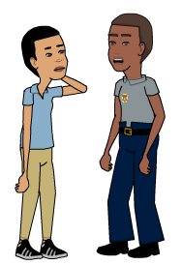

|  |  |  |
| --- | --- | --- |
| Victims may appear:   * Expressive: crying, enraged, smiling * Controlled: numb, in shock, quiet, composed |  | Victims may experience:   * Flashbacks, nightmares, anxiety * Fear, hopelessness * Anger, irritability, hyper vigilance * Post-Traumatic Stress Disorder (PTSD) * Depression and suicidal feelings |

Pixton.com

**Responding to a Victimized Resident**

When talking to a resident who has been sexually abused, remember:

* They may need time to establish trust or may prefer to speak with someone they already trust
* Their story may seem inconsistent or illogical, due to trauma; this does not mean they are lying
* Unless you are an investigator, stick to basic questions like: “Are you injured? Are you or someone else in immediate danger?”

**Common Reactions to Abuse**

There is no “right” way for a person to respond to sexual abuse; common reactions to trauma vary greatly, but often include: