Agency/Facility Name
PREA REFRESHER: Juvenile Detention
PREA Basics

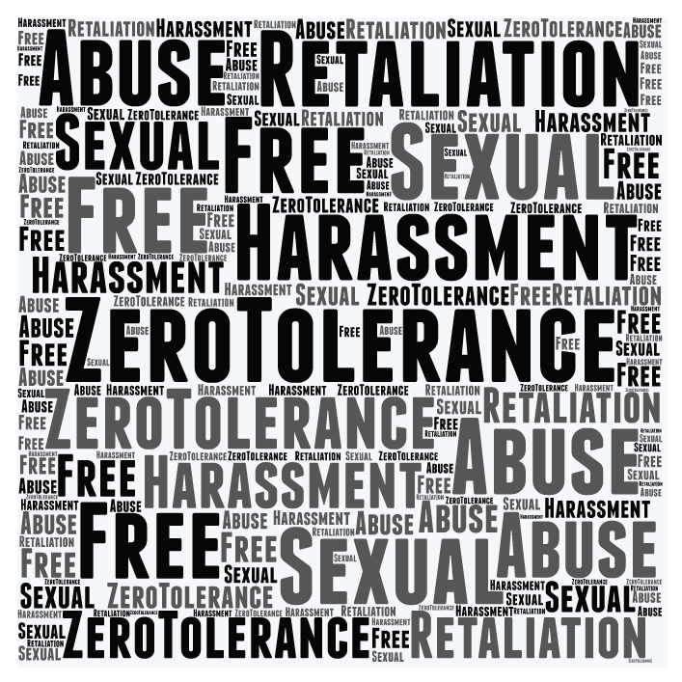
Zero Tolerance Policy
Residents have a right to:
- Be free from sexual abuse and sexual harassment
- Report and get help if they are abused or harassed
- Be protected from retaliation if they report abuse or harassment, or cooperate in an investigation

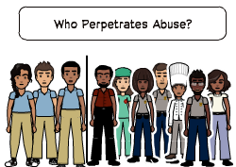
Detecting Signs of Sexual Abuse
Look for changes in behavior, like residents who start:

- Acting out or keeping to themselves  - Refusing to shower or showering more frequently | - Refusing to leave or return to their room  - Avoiding — or clinging to — certain residents or staff
NOTE: Check on any resident who shows these changes in behavior, but keep in mind that these also are signs of trauma or emotional distress unrelated to sexual abuse. Keep in mind that some residents may not show any outward reaction.

ese may be signs of trauma or emotional distress unrelated to sexual abuse. Some inmates may not show any outward reaction.

Dynamics of Sexual Abuse in Juvenile Facilities
Federal research shows that:
- Nearly 10% of youth in juvenile facilities were sexually abused in the previous 12 months

- More than 80% of sexual assaults of male residents are committed by staff
- Female residents are nearly twice as likely to be abused by another resident than by staff

Pixton.com
Staff
Residents

