Agency/Facility Name
PREA REFRESHER: Community Confinement
Resident Support Services

Resident Support Services
This agency has partnered with [advocacy organization name] to provide free, confidential support services to residents who have experienced sexual abuse (in confinement or at any time in their lives). Residents can access these services by:
- Dialing [number] on any dorm phone, community phone or their cell phone
- Writing to the organization at [insert address]

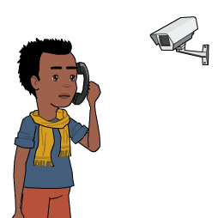
Pixton.com
Privacy
Calls to community advocates are not monitored or recorded. This is to ensure that the communications take place in as confidential a manner as possible. Residents may also choose to contact the community advocate using their cell phone.

Advocates will explain to residents that most calls will be confidential but that they will notify the facility if a resident is being inappropriate or say they plan to hurt themselves, someone else, or plan to run away from the facility, [insert other limits to confidentiality or mandatory reporting].
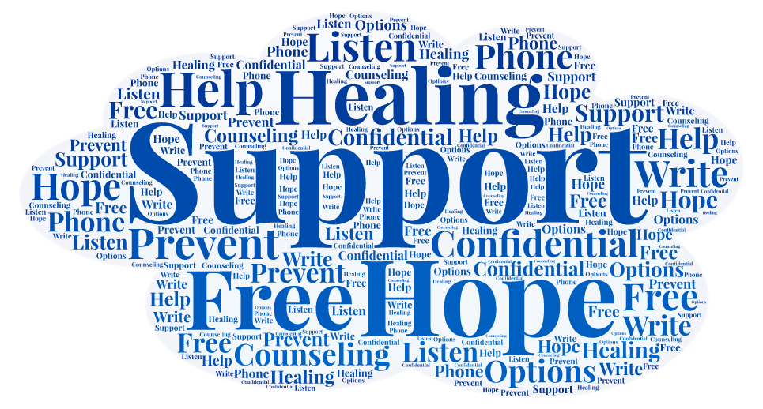
What Services Are Provided?
[Advocacy organization name] advocates can provide:
- Crisis intervention
- Information about reporting sexual abuse and sexual harassment
- Follow-up support
- Referrals for community-based services

