Agency/Facility Name
PREA REFRESHER: Community Confinement
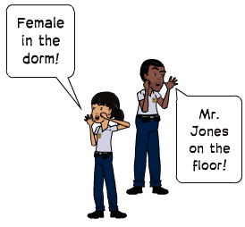
Resident Privacy
Pat Searches and Urine Drops
Searches and observing urine drops help ensure facility safety and security. Searches and urine drops can be traumatizing and need to be done professionally and respectfully.

- Conduct pat searches and urine drops consistent with agency policy and procedures — variations in practice can create confusion and distress for residents
- Know agency procedures for searching transgender residents
- Explain what you are doing during searches, especially if the resident shows signs of distress
- Do not joke or make off-topic comments during searches or urine drops
- Urine drops must be observed by staff of the same gender as the resident
NOTE: You must make an announcement each time you enter an opposite gender unit only when there are no other staff members of your gender present.

- Use clear, professional language
- Speak loudly enough so you can be heard over noise and conversations
- Be respectful during sleeping hours so as not to wake up residents

Housing Unit Announcements
Staff must announce their presence when entering an opposite gender sleeping area or restroom. Announcing gives residents the opportunity to dress or cover themselves and maintain reasonable privacy.
Please keep in mind that you should:

Pixton.com
Pixton.com
Privacy Does Not Compromise Security
- Residents must be able to shower, change clothes, and use the toilet without opposite gender staff viewing them (except during routine security checks)
- Avoid staring while residents are fully or partially undressed

