Agency/Facility Name
PREA REFRESHER: Community Confinement
Professional Communication and Boundaries
Professional Communication
When staff treat residents respectfully, residents will ask for help when needed. Staff should aim to communicate with residents in a manner that is open, honest, and professional. Here are some tips to achieve an appropriate balance:
- Avoid slang and nicknames
- Always use respectful language when speaking with residents and to one another
- Address all residents as by their last name to avoid misusing pronouns
- Never use offensive terms when referring to LGBTI residents
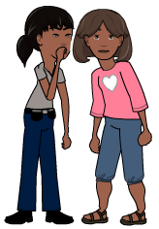
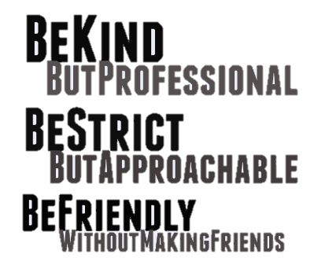
Compromised Professionalism
Developing personal relationships with certain residents leads to:
- A lack of trust among staff
- Diminished facility safety, including more abuse and harassment
- Increased power for favored residents
Pixton.com
Appropriate Interactions
Staff can avoid inappropriate behavior while still maintaining open communication with residents by:
- Allowing small talk but stopping it if it becomes personal
- Enforcing policies in a way that conveys respect and compassion
- Actively listening to residents but letting them know you have duties to fulfill

