**Agency/Facility Name**

**PREA REFRESHER: Community Confinement**

**Handling Disclosures of Abuse**

**Disclosures**

A resident can report to any staff, volunteer, or contractor. It is your duty to handle a report with sensitivity and compassion. Make sure to:

* Stay calm and professional, and let the victimized resident know that you take this issue very seriously
* Explain steps this facility will take to keep them safe from the alleged abuser going forward
* Assure them that they will be offered immediate medical care and support

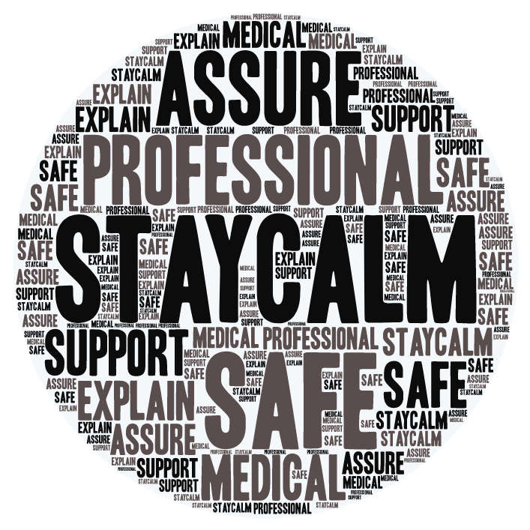

Victims may appear

* Expressive: crying, enraged, smiling
* Controlled: numb, in shock, composed, quiet

Victims may experience

* Flashbacks, nightmares, anxiety
* Fear, hopelessness
* Anger, irritability, hyper vigilance
* Post-Traumatic Stress Disorder (PTSD)
* Depression and suicidal feelings

**Common Reactions to Abuse**

There is no “right” way for a person to respond to sexual abuse; common reactions to trauma vary greatly, but often include:

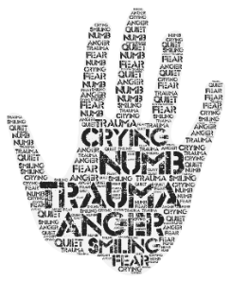

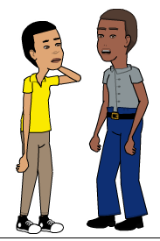

Pixton.com

**Responding to a Victimized Resident**

When talking to a resident who has been sexually abused, remember:

* They may need time to establish trust or may prefer to speak with someone they already trust
* Their story may seem inconsistent or illogical due to trauma; this does not mean they are lying
* Unless you are an investigator, stick to basic questions like: (1) “Are you injured?” (2) “Are you or someone else in immediate danger?”