Agency/Facility Name
PREA Refresher: Community Confinement
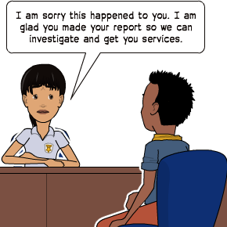
Encouraging Residents to Report Sexual Abuse
Pixton.com
Reporting Improves Facility Safety
If a resident has been sexually abused or harassed, this facility wants to know so we can keep the resident safe and provide them the necessary support and resources.

Unfortunately, sexual abuse is underreported and this agency wants to change that.

As staff, your role is NOT to determine the validity of a PREA report. You should always:
- Take ALL reports seriously
- Respond immediately following agency response protocols
- Tell a supervisor

Remember – Treat all reports of sexual abuse or sexual harassment as credible. All reports will be thoroughly investigated and residents will be protected from retaliation. Where the resident is acting in good faith and with a reasonable belief that the abuse occurred, discipline is NOT appropriate.
Consequences for misusing PREA
- The placement could be revoked and the resident returned to prison if a report is submitted in bad faith
- A finding of “unsubstantiated” or “unfounded” does not mean the resident is lying or the report is false
Pixton.com
False PREA reports happen.
But why?
- To seek protection from bullying or physical threats
- To get staff or residents in trouble
- To attempt to get basic needs met (medical care, hygiene items, etc.)

