Agency/Facility Name
PREA REFRESHER: Community Confinement
Investigations
Who Investigates PREA Allegations?
- Trained facility investigators conduct internal administrative investigations
- Trained investigators from [investigative agency] conducts criminal investigations, if applicable

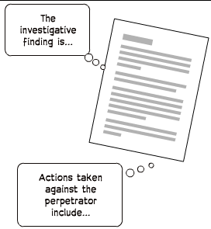
Pixton.com
Resident Notification
Residents still in custody must be notified:
- Of the investigation’s outcome
- If a staff abuser is no longer allowed to work in the resident’s dorm or facility or has been terminated by our agency
- If this agency learns the alleged [staff/resident] abuser has been indicted or convicted on a charge related to the sexual abuse allegation
Unsubstantiated
It cannot be determined if
the allegation happened
Possible Investigation Outcomes
Unfounded
The allegation was determined to
have most likely
not occurred

Substantiated
The allegation was determined to
have most likely occurred

