**Agency/Facility Name**

**PREA REFRESHER: Community Confinement**

**PREA Basics**

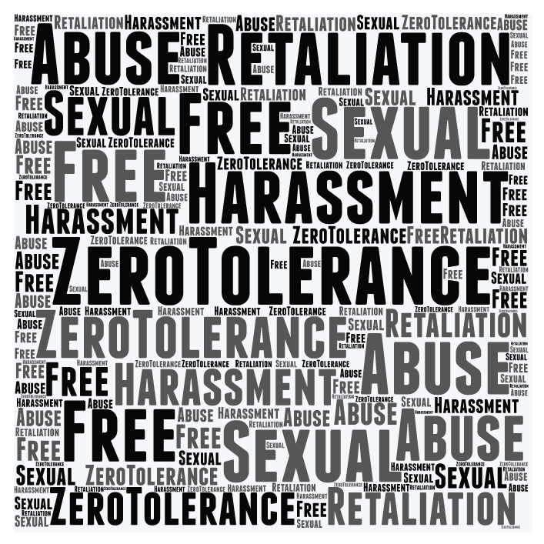

**Zero Tolerance Policy**

Residents have a right to:

* Be free from sexual abuse and sexual harassment
* Report and get help if they are abused or harassed
* Be protected from retaliation if they report abuse or harassment or cooperate in an investigation

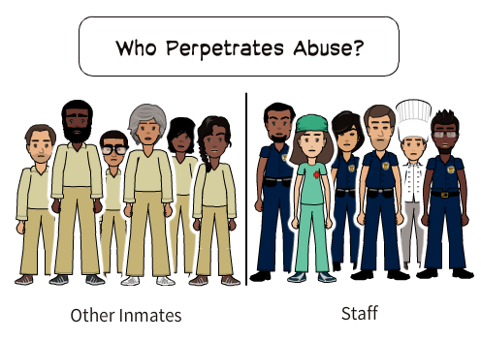

**Dynamics of Sexual Abuse in Detention**

Not a lot is known about sexual abuse in community confinement settings.

However, a national survey conducted by the federal government shows that sexual abuse of residents in community confinement settings is perpetrated twice as often by staff as by other residents.



***Note: Check on any resident who exhibits any of these signs. Remember that these may be signs of trauma or emotional distress unrelated to sexual abuse; some residents who have been sexually abused may not show any of these signs.***

* Refusing to leave or return to their cell
* Avoiding — or clinging to — certain residents or staff
* Acting out or keeping to themselves
* Refusing to shower or showering more frequently

**Detecting Signs of Sexual Abuse**

Look for changes in behavior, like residents who start:

Pixton.com

Residents

Staff